Department of Veterans Affairs

Veterans Health Administration (VHA)

Office of Informatics and Analytics

Innovation Program

OneVA Pharmacy Implementation Project

System Design Document (SSD)

(CLIN #0002AC)

Business Information Technology Solutions, Inc.

3190 Fairview Park Drive, Suite 315

Falls Church, VA 22042

Task Order: VA-118-15-Q-0745



Version 2.2

March 2016

Revision History

Note: The revision history cycle begins once changes or enhancements are requested after the Requirements Specification Document has been baselined.

| Date | Version | Description | Author |
| --- | --- | --- | --- |
| 10/26/2015 | 0.1 | Initial Draft | Kathy Coupland |
| 10/29/2015 | 0.2 | Updated Sections 2, 3, 4, 5, and 8 | Tony Burleson |
| 11/13/2015 | 0.3 | Updated Diagrams, spelled out acronyms, and applied TJ Cope’s comments. Added Brad Fisher’s updates. | Kathy Coupland |
| 11/28/2015 | 0.4 | Updated diagram and modified two requirements. | Kathy Coupland |
| 12/28/2015 | 0.5 | Updated section 6.2 and VAeMI areas | Tony Burleson |
| 12/30/2015 | 1.0 | Baseline | Kathy Coupland |
| 01/04/2016 | 1.1 | Update Section 6.5 & namespace update. | Kathy Coupland |
| 03/02/2016 | 2.0 | Update to modify the VAeMI-Middleware direction from development of self-service components to integration directly with VAeMI-Middleware. | Kathy Coupland |
| 03/03/2016 | 2.1 | Updated VAeMI-Middleware areas to accommodate the direction from a Self-service model to full-service. | Tony Burleson |
| 03/04/2016 | 2.2 | Technical edit and respond to the AERB comments. | Kathy Coupland |

Table of Contents

1. Introduction 10

1.1. Scope 10

1.2. User Profiles 10

1.3. Acronyms and Abbreviations 10

1.4. Processes and References 12

2. Background 12

2.1. Overview of the System 12

2.2. Overview of the Business Process 13

2.3. Overview of the Significant Requirements 13

2.3.1. Business Rules 13

2.3.2. Design Constraints 14

2.3.3. Documentation Specifications 14

2.3.4. Functional Requirements 14

3. Conceptual Design 14

3.1. Conceptual Application Design 14

3.1.1. Application Context 15

3.1.2. High-Level Application Design 15

3.1.2.1. Use Case Name: View Orders 16

3.1.2.2. Use Case Name: Dispense Local Order 17

3.1.2.3. Use Case Name: Dispense Remote Order 18

3.1.3. Application Locations 19

3.2. Conceptual Data Design 19

3.2.1. Project Conceptual Data Model 19

3.2.2. Database Information 19

3.2.2.1. Remote Prescription Log File 19

3.2.2.2. Refill Multiple (#52.1) of the Prescription File (#52) 23

3.2.2.3. Partial Multiple (#52.2) of the Prescription File (#52) 23

3.2.2.4. Remote Prescription Log (#52.09) 24

3.2.3. User Interface Data Mapping 25

3.2.3.1. Application Screen Interface 25

3.2.3.2. Application Report Interface 25

3.2.3.2.1. Prescriptions we have filled for other facilities 25

3.2.3.2.2. Our prescriptions, filled by other facilities 27

3.2.3.2.3. All Remote activity 28

3.2.3.3. Unmapped Data Element 29

3.3. Conceptual Infrastructure Design 30

3.3.1. System Criticality and High Availability 30

3.3.2. Special Technology 30

3.3.3. Technology Locations 31

3.3.4. Conceptual Infrastructure Diagram 31

3.3.4.1. Location of Environments and External Interfaces 31

3.3.4.2. Conceptual Production String Diagram 31

4. System Architecture 32

4.1. Hardware Architecture 32

4.2. Software Architecture 32

4.2.1. VAeMI ESB 32

4.2.2. HDR/CDS Endpoint 33

4.2.3. Sequence Diagrams 35

4.2.3.1. View Order 36

4.2.3.2. Dispense Remote Order Sequence Diagram 36

4.2.4. Design Rationale 37

4.2.5. HL7 Protocol 37

4.3. Network Architecture 38

4.4. Service Oriented Architecture / ESS 38

4.5. Enterprise Architecture 39

5. Data Design 40

5.1. DBMS Files 40

5.1.1. Refill Multiple (#52.1) of the Prescription File (#52) 40

5.1.2. Partial Multiple (#52.2) of the Prescription File (#52) 40

5.1.3. Remote Prescription Log (#52.09) 40

5.2. Non-DBMS Files 42

5.3. Data View 42

6. Detailed Design 43

6.1. Hardware Detailed Design 43

6.2. Software Detailed Design 44

6.2.1. Conceptual Design 44

6.2.1.1. Product Perspective 44

6.2.1.1.1. User Interfaces 44

6.2.1.1.2. Hardware Interfaces 44

6.2.1.1.3. Software Interfaces 45

6.2.1.1.4. Communications Interfaces 45

6.2.1.1.5. Memory Constraints 45

6.2.1.1.6. Special Operations 45

6.2.1.2. Product Features 45

6.2.1.3. User Characteristics 46

6.2.1.4. Dependencies and Constraints 46

6.2.2. Specific Requirements 46

6.2.2.1. Database Repository 46

6.2.2.2. System Features 46

6.2.2.3. Design Element Tables 46

6.2.2.3.1. Routines (Entry Points) 46

6.2.2.3.1.1. PSOORNE2 46

6.2.2.3.1.2. PSOORUT1 48

6.2.2.3.1.3. PSOROS 49

6.2.2.3.1.4. PSORRD 50

6.2.2.3.1.5. PSORREF 51

6.2.2.3.1.6. PSORREF0 52

6.2.2.3.1.7. PSORREF1 53

6.2.2.3.1.8. PSORRP 54

6.2.2.3.1.9. PSORRPA1 55

6.2.2.3.1.10. PSORRX1 56

6.2.2.3.1.11. PSORWRAP 57

6.2.2.3.1.12. PSORX1 58

6.2.2.3.2. Templates 60

6.2.2.3.2.1. PSO LM REMOTE ORDER SELECTION 60

6.2.2.3.3. Bulletins 61

6.2.2.3.4. Data Entries Affected by the Design 61

6.2.2.3.5. Unique Record(s) 62

6.2.2.3.6. File or Global Size Changes 62

6.2.2.3.6.1. Global 62

6.2.2.3.6.2. Files 62

6.2.2.3.7. Mail Groups 65

6.2.2.3.8. Security Keys 65

6.2.2.3.9. Options 65

6.2.2.3.9.1. Pharmacy Remote Prescription Manager Options 65

6.2.2.3.10. Protocols 68

6.2.2.3.11. Remote Procedure Call (RPC) 74

6.2.2.3.12. Constants Defined in Interface 74

6.2.2.3.13. Variables Defined in Interface 74

6.2.2.3.14. Types Defined in Interface 74

6.2.2.3.15. GUI 74

6.2.2.3.16. GUI Classes 74

6.2.2.3.17. Current Form 74

6.2.2.3.18. Modified Form 75

6.2.2.3.19. Components on Form 75

6.2.2.3.20. Events 75

6.2.2.3.21. Methods 75

6.2.2.3.22. Special References 75

6.2.2.3.23. Class Events 75

6.2.2.3.24. Class Methods 75

6.2.2.3.25. Class Properties 75

6.2.2.3.26. Uses Clause 75

6.2.2.3.27. Forms 75

6.2.2.3.28. Functions 75

6.2.2.3.29. Dialog 75

6.2.2.3.30. Help Frame 75

6.2.2.3.31. HL7 Application Parameter 76

6.2.3. HL7 Protocols 76

6.2.4. HL7 Sender and Receiver Applications 78

6.2.5. Sender and Receiver Logical Links 79

6.2.5.1.1. HL7 Logical Link 81

6.2.5.1.2. COTS Interface 82

6.3. Network Detailed Design 82

6.4. Security and Privacy 82

6.4.1. Security 82

6.4.1.1. Secure Sockets Layer (SSL) 82

6.4.1.2. Authentication and Authorization 82

6.4.1.3. Remote Prescription Locking 82

6.4.2. Privacy 83

6.5. Service Oriented Architecture / ESS Detailed Design 83

6.5.1. Service Description for <Consumed Service Name> 83

6.5.2. Service Design for <Provided Service Name> 83

7. External System Interface Design 83

7.1. Interface Architecture 83

7.2. Interface Detailed Design 83

7.3. Acknowledgement Codes 83

7.4. Order Control Codes 84

7.5. Remote Prescription Query Transaction 84

7.5.1. Remote Prescription Query Request 84

7.5.2. Sample QBP^Q13 Request 85

7.5.3. Remote Prescription Query Response 85

7.5.4. Sample RTB^K13 Response 87

7.6. Remote Prescription Dispense Transaction 87

7.6.1. Remote Description Dispense Request 87

7.6.2. Remote Description Dispense Response 89

8. Human-Machine Interface 91

8.1. Interface Design Rules 91

8.2. Inputs 91

8.3. Outputs 91

8.4. Navigation Hierarchy 92

8.4.1. Prescription Display 92

9. Attachment A – Approval Signatures 95

A.1. Identification of Technology and Standards 96

A.2. Constraining Policies, Directives and Procedures 96

A.3. Requirements Traceability Matrix 96

A.4. Packaging and Installation 96

A.5. Design Metrics 96

Table of Figures

Figure 1: OneVA Pharmacy Design Overview 13

Figure 2: Application Architectural Diagram 15

Figure 3: High-level Context Diagram 16

Figure 4: Remote Report Content Example 27

Figure 5: Remote Report Content Example 28

Figure 6: Remote Report Content Example 29

Figure 7: OneVA Pharmacy Components 30

Figure 8: Conceptional Production String Diagram 32

Figure 9: HDR endpoint methods and parameters 33

Figure 10: Template of the SOAP Request 34

Figure 11: Diagram of the HDR's pharmacy.xsd’s OutpatientMedicationPromise 35

Figure 12: View Order Sequence Diagram 36

Figure 13: Dispense Remote Order Sequence Diagram 37

Figure 14: VistA and VAeMI ESB Integration 38

Figure 15: HL7/MLLP and SOAP/https Integration 39

Figure 16: Communications Interface 45

Figure 17: Example of Configuration of a Protocol to handle QBP-Q13 Events 76

Figure 18: Example of Configuration of a Protocol to handle QBP-Q13 Events 77

Figure 19: Example of Configuration of a Protocol to handle QBP-Q13 Events 77

Figure 20: Example of Configuration of a Protocol to handle QBP-Q13 Events 78

Figure 21: Receiving HL7 Application Configuration 78

Figure 22: Sending HL7 Application Configuration 79

Figure 23: Example of Configuration of Logical Links 79

Figure 24: Example of Configuration of Logical Links 80

Figure 25: Example of Configuration of Logical Links 80

Figure 26: Example of Configuration of Logical Links 81

Figure 27: Navigational Hierarchy 92

Table of Tables

Table 1: Acronym & Abbreviation Table 10

Table 2: Special Technology Requirements 30

Table 3: Technology Components Used 31

Table 4: MLLP HL7 Endpoint Messages 32

Table 5: Variables and Description 34

Table 6: Global Placement and Protection 62

Table 7: Files 62

Table 8: REFILL Sub file (#52.1) 62

Table 9: PARTIAL FILL sub file (#52.2) 63

Table 10: Remote Prescription Log (#52.09 63

Table 11: Acknowledgement Codes 83

Table 12: Order Control Codes 84

Table 13: Remote Prescription Query Request 84

Table 14: QPD Field Description and Commentary 84

Table 15: PID Field Description and Commentary 85

Table 16: RCP Field Description and Commentary 85

Table 17: Remote Prescription Query Response 85

Table 18: RCP Field Description and Commentary 86

Table 19: Remote Description Dispense Request 87

Table 20: PID Field Description and Commentary 87

Table 21: ORC Field Description and Commentary 88

Table 22: RXO Field Description and Commentary 89

Table 23: Remote Description Dispense Response 89

Table 24: RXD Field Description and Commentary 90

# Introduction

Leadership at the Department of Veterans Affairs (VA) initiated the OneVA Pharmacy project to enhance and integrate the OneVA Pharmacy prototype into VistA. The OneVA Pharmacy module will provide the Department of Veterans Health Administration (VHA) the capability to allow Veterans travelling across the United States to refill their active VA prescription at any VA Pharmacy regardless of where the prescription originated. The module expands available pharmacy information in VistA to pharmacists providing direct access to any active and refillable prescription from any VA Healthcare System. The OneVA Pharmacy project modifies the existing prototype software to expand its current capability and includes the development of documentation to support a national rollout in 2016.

The OneVA Pharmacy module and this implementation provides a foundation to build and extend new capabilities to the Veteran, who are better served by integrating virtual care into pharmacies, using technology to close the gap between the previous quality of information, and the Veteran's level of engagement. A well-designed OneVA Pharmacy builds upon the history of the VHA, and advances in modern technology to allow Veterans to take a more active role in their own health care.

## Scope

This System Design Document (SDD) will define the high level design for the OneVA Pharmacy project objectives. It defines and describes system components, architectural views, system constraints, and design rationale.

## User Profiles

The user profile of the OneVA Pharmacy module are those users, specifically pharmacists, that use the Pharmacy [PSO LM BACKDOOR ORDERS] menu to dispense prescriptions.

## Acronyms and Abbreviations

The following table provides the list of acronyms used throughout the document along with their descriptions.

Table 1: Acronym & Abbreviation Table

| Acronym/Abbreviation | Description |
| --- | --- |
| ADT | Admission Discharge Transfer |
| AITC | Austin Information Technology Center |
| API | Application Programming Interface |
| BITS | Business Information Technology Solutions, Inc. |
| CDS | Clinical Data Services |
| CLIN | Contract Line Item Number |
| DFN | Data File Number |
| DHCP | Dynamic Host Configuration Protocol |
| eMI | Enterprise Messaging Infrastructure |
| ESB | Enterprise Service Bus |
| HDR | Health Data Repository |
| HL7 | Health Level 7 |
| ICN | Integration Control Number |
| IOC | Initial Operating Capability |
| IT | Information Technology |
| MLLP | Minimal Lower Layer Protocol |
| MUMPS | Massachusetts General Hospital Utility Multi Programming System |
| MVI | Master Veteran Index |
| NPI | National Patient Index |
| OIA | Office of Informatics and Analytics |
| PSO | Outpatient Prescription Pharmacy |
| [PSO LM BACKDOOR ORDERS] | Patient Prescription Processing |
| RDNG | IBM Rational DOORS Next Generation |
| RSD | Requirements Specification Document |
| RTM | Requirements Traceability Matrix |
| SDD | System Design Document |
| SME | Subject Matter Expert |
| SOAP | Simple Object Access Protocol |
| TRM | Technical Reference Model |
| VA | Department of Veterans Affairs |
| VHA | Department of Veterans Health Administration |
| VistA | Veterans Health Information Systems and Technology Architecture |

## Processes and References

The references that support the implementation of the OneVA Pharmacy SDD are:

* [Requirements Specification Document (RSD)](http://vaww.oed.portal.va.gov/pm/iehr/vista_evolution/pharmacy/OneVAPharm/Shared%20Documents/Forms/AllItems.aspx?RootFolder=%2Fpm%2Fiehr%2Fvista%5Fevolution%2Fpharmacy%2FOneVAPharm%2FShared%20Documents%2FOneVA%20Pharmacy%20Option%20Year%20%2D%20Implementation%2FRSD&InitialTabId=Ribbon%2EDocument&VisibilityContext=WSSTabPersistenc" \o "OneVA Pharmacy RSD LINK on VA SharePoint)

# Background

## Overview of the System

The overall OneVA Pharmacy system design is partitioned into two main components. They are:

1. VistA Server
2. Enterprise Messaging Infrastructure (eMI) Enterprise Service Bus (ESB) (VAeMI)

The VistA Server is the user interface where a pharmacist uses the “Patient Prescription Processing [PSO LM BACKDOOR ORDERS]” menu option to query for and refill, patient’s active and refillable prescriptions; local and remote. The VAeMI receives requests from VistA to query the Health Data Repository/Clinical Data Service (HDR/CDS) for a patient’s active and refillable remote prescriptions. The VistA server and the VAeMI communicate with each other using Health Level 7 (HL7) v2.5.1 over Minimal Layer Protocol (MLLP). Communication to the HDR/CDS will also be via SOAP web services.

The following figure displays the OneVA Pharmacy system design approach.

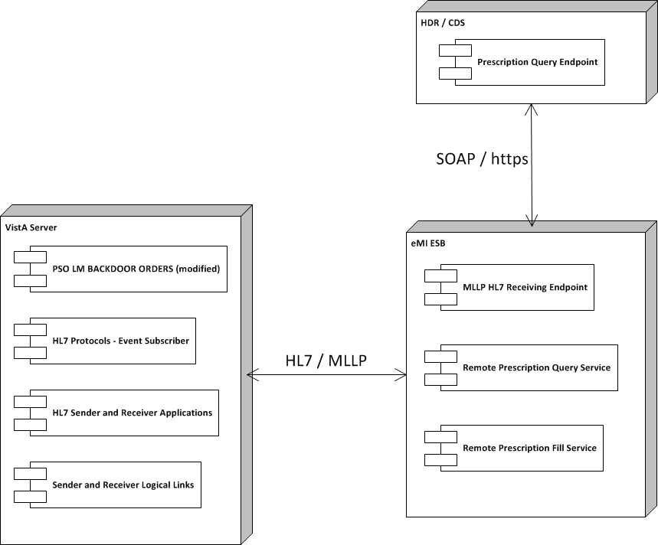

Figure 1: OneVA Pharmacy Design Overview

## Overview of the Business Process

OneVA Pharmacy provides VistA the functionality to allow pharmacists to refill a prescription at any VA pharmacy location. It decrements the patients number of remaining refill balance at the originating pharmacy and manages controlled substances by displaying a message that a controlled substance cannot be refilled outside of the originating pharmacy.

## Overview of the Significant Requirements

### Business Rules

Business rules are a high-level functionality condition that the system must support in order to complete the business of the organization. Business rules describe the operations, definitions, and constraints that apply to an organization. The high-level overview of the business rules for OneVA Pharmacy project includes filtering on only ‘active’ prescriptions with one or more refills remaining and the date of the next refill is no earlier than one week. The prescription cannot be a controlled substance and the patient must be registered in one or more VistAs.

The detailed business rules for the OneVA Pharmacy project can be found in the OneVA Pharmacy Requirements Specification Document (RSD), located on the VA SharePoint. The OneVA Pharmacy RSD can be accessed by following this LINK.

### Design Constraints

Design constraints mandate design decisions that the system must support in order to complete the business of the organization. The high-level overview of the design constraints for the OneVA Pharmacy project includes using the VistA routine ‘Patient Prescription Processing’ [PSO LM BACKDOOR ORDERS] to access local patient information; HDR/CDS will be accessed via the VAeMI to retrieve data for the medication profile screen; and the VAeMI and the VistA Dynamic Host Configuration Protocol (DHCP) HL7 interface will be integrated for information exchange between VistA systems.

The details for the design constraints for the OneVA Pharmacy project can be found in the OneVA Pharmacy RSD, located on the VA SharePoint. The OneVA Pharmacy RSD can be accessed by following this LINK.

### Documentation Specifications

The goal of the ‘Documentation Specifications’ is to ensure necessary documentation is developed according to standard. The product and project documentation for the OneVA Pharmacy project can be found in the OneVA Pharmacy RSD, located on the VA SharePoint. The OneVA Pharmacy RSD can be access by following this LINK.

### Functional Requirements

A requirement specifies functions that the application should be able to perform and constraints on application performance. The high-level overview functional specifications for the OneVA Pharmacy project includes displaying the Medication Profile for a patient from all other facilities, capability to refill full or partial active prescription for a patient at remote site other than the site the prescription originated from, dispense local refills as currently designed, generate a prescription label, and generate new reports.

The functional requirements are detailed in the OneVA Pharmacy RSD, located on the VA SharePoint. The OneVA Pharmacy RSD can be accessed by following this LINK.

# Conceptual Design

## Conceptual Application Design

The software architecture for the OneVA Pharmacy project follows the peer-to-peer architectural model, where one VistA node sends and receives data to and from another VistA node. The system utilizes the ESB model providing message routing and coordination of multiple services to view a patient’s prescription record and modify that record in remote VistA systems.

### Application Context

The following diagram displays the VistA application and how it will exist within the design of the ESB model when the OneVA Pharmacy project is implemented.

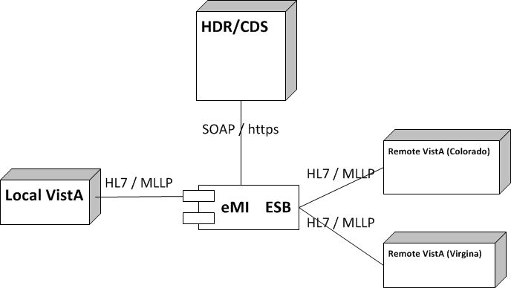

Figure 2: Application Architectural Diagram

The entities displayed in the Application Architecture Diagram are explained as follows:

* VistA is the user interface for initiating prescription queries and requesting prescription refills from remote VistAs.
* VAeMI ESB is the messaging component to handle MLLP HL7 endpoints, SOAP web service call to the HDR/CDS.

### High-Level Application Design

The High-Level Application Design identifies the major components of the application and the relationships of the major application components to each other. Use Cases are being used in this SDD to document the logical application design for the OneVA Pharmacy project.

The following use cases have the pre-condition that the patient is known and registered in one or more VistAs.

Note: The act of registering a patient in VistA triggers an Admission Discharge Transfer (ADT) registration message to be sent to the Master Veteran Index (MVI) located in the Austin Information Technology Center (AITC). For each new patient, the MVI creates and assigns an Integration Control Number (ICN) and sends this number among other information to the initiating VistA in response to the ADT message. Further the MVI, stores and correlates the local VistA Patient Data File Numbers (DFNs) with the national ICN. One national patient ICN is correlated to (among other systems’ patient identifiers) many local VistA patient identifiers. The ICN enables the sharing of patient data between operationally diverse systems.



Figure 3: High-level Context Diagram

#### Use Case Name: View Orders

The ‘View Orders’ Use Case describes the process for users to view all of a patient’s active prescription orders. This process allows a user to view prescription order information in one place whether the order originated from a local or remote VistA instance.

Actors

* User (Provider, Pharmacist, etc.)
* Local VistA instance
* HDR/CDS
* VAeMI ESB (proxy to remote VistAs)

Pre-Conditions

* Patient must have an ICN
* User has accessed the PBM Manager Menu [PSU PBM MANAGER MENU] (no separate Security Keys required)

Flow of Events

1. User enters the Medication Profile screen.
2. The local VistA instance will retrieve the local prescriptions.
3. The local VistA instance will send a request via the VAeMI ESB to the HDR/CDS with the patient identifiers to retrieve the prescriptions with a status of ‘Suspended’, ‘Active’, or ‘Hold’ from all previous treatment facilities excluding local facility.
4. The local VistA instance will display all prescriptions.

Exceptions

* 3a. VAeMI ESB is not accessible.
* 3b. HDR/CDS is not accessible.

System Message

* 1a. Please wait. Checking for remote prescriptions. This may take a moment…
* 1b. Eligibility: RX PATIENT STATUS: OPT NSC//
* 3a. The system is down or not responding. Could not query remote prescriptions. Press RETURN to continue.

#### Use Case Name: Dispense Local Order

The “Dispense Local Order’ Use Case describes the process for users to dispense local order. Note: Documented in the RSD there is a business requirement that the system shall provide the ability to dispense local refills as currently designed therefore this Use Case is being presented for test cases development and documentation purpose.

Actors

* User (Provider, Pharmacist, etc.)
* Local VistA Instance

Pre-Conditions

* Patient must have an ICN.
* Local VistA instance has the required amount of prescribed medication inventory on-hand.
* User has accessed the PBM Manager Menu [PSU PBM MANAGER MENU] (no separate Security Keys required

Flow of Events

1. User selects RF (Refill) for a local prescription from the Medication Profile screen.
2. The local VistA will update the prescription; decrement refills, etc.
3. The local VistA will dispense the prescription.

Alternate Flow

1. User selects PF (Partial fill) for a local prescription from the Medication Profile screen.
2. The local VistA will update the prescription; partial fill date, etc.
3. The local VistA will dispense the prescription.

#### Use Case Name: Dispense Remote Order

The ‘Dispense Remote Order’ Use Case describes the process for users to dispense a remote order.

Actors

* User (Provider, Pharmacist, etc.)
* Local VistA Instance
* VAeMI ESB
* Remote VistA Instance

Pre-Conditions

* Patient must have an ICN.
* Local VistA instance has the required amount of prescribed medication inventory on-hand.
* User has accessed the PBM Manager Menu [PSU PBM MANAGER MENU] (no separate Security Keys required

Flow of Events

1. User selects a remote prescription and RF (Refill) from the Medication Profile screen.
2. The local VistA instance will send a refill order request to the VAeMI ESB.
3. The VAeMI ESB will route the refill order request to remote VistA instance.
4. The remote VistA will conduct order checks.
5. The remote VistA will update the prescription order; decrement refills, without affecting inventory.
6. The local VistA instance will dispense medication.

Alternate Flow

1. User selects a remote prescription and PF (Partial fill) from the Medication Profile screen.
2. The local VistA instance will send a partial fill order request to the VAeMI ESB.
3. The VAeMI ESB will send partial fill order request to remote VistA instance.
4. The remote VistA will conduct order checks.
5. The remote VistA will update the prescription order; update partial fill date without affecting inventory.
6. The local VistA instance will dispense medication.

Exceptions

* 2a. VAeMI ESB is not accessible.
* 3a. The remote VistA is not accessible
* 3b. The prescription is a controlled substance
* 4a. The remote VistA instance fails the order.

System Message

* 1a. Please wait. Checking for remote prescriptions. This may take a moment…
* 1b. Eligibility: RX PATIENT STATUS: OPT NSC//
* 3a. The system is down or not responding. Could not query remote prescriptions. Press RETURN to continue.

### Application Locations

The OneVA Pharmacy module extends the existing VistA to provide pharmacists direct access to any active, refillable prescription from any VA Healthcare System. However, integration with the VAeMI-middleware and the HDR/CDS repository are critical for the success of the deployment. but are outside the development of the OneVA Pharmacy team’s deliverables.

## Conceptual Data Design

### Project Conceptual Data Model

Not applicable.

### Database Information

#### Remote Prescription Log File

STANDARD DATA DICTIONARY #52.09 -- REMOTE PRESCRIPTION LOG FILE

                                                    MAR 4,2016@12:07:28  PAGE 1

STORED IN ^PSRXR(52.09,  *** NO DATA STORED YET ***   SITE: TEST.CHEYENNE.MED.VA .GOV   UCI: VISTA,ROU DATA NAME GLOBAL DATA ELEMENT TITLE LOCATION TYPE

              DD ACCESS: @

              RD ACCESS: @

              WR ACCESS: @

             DEL ACCESS: @

           LAYGO ACCESS: @

           AUDIT ACCESS: @

        (NOTE: Kernel's File Access Security has been installed in this UCI.)

CROSS REFERENCED BY: LOG DATE/TIME(B), PATIENT(C), RX NUMBER(D), SITE NUMBER(E)

52.09,.01     LOG DATE/TIME          0;1 DATE (Required)

              INPUT TRANSFORM:  S %DT="ESTR" D ^%DT S X=Y K:Y<1 X

              LAST EDITED:      APR 26, 2014

              HELP-PROMPT:      Enter the date/time for this transaction.

              DESCRIPTION:      This is the date/time associated with this remote prescription transaction. The date/tim represents the date/time the message was processed and filed locally.

              CROSS-REFERENCE:  52.09^B

                                1)= S ^PSRXR(52.09,"B",$E(X,1,30),DA)=""

                                2)= K ^PSRXR(52.09,"B",$E(X,1,30),DA)

52.09,.02     PATIENT                0;2 POINTER TO PATIENT FILE (#2)                                 (Required)

              LAST EDITED:      APR 26, 2014

              HELP-PROMPT:      Enter the Patient for which this refill or partial fill occured.

              DESCRIPTION:      This is the patient for which a refill or partial fill request was generated.

              CROSS-REFERENCE:  52.09^C

                                1)= S ^PSRXR(52.09,"C",$E(X,1,30),DA)=""

                                2)= K ^PSRXR(52.09,"C",$E(X,1,30),DA)

                                Cross reference for patient IEN. 52.09,.03     RX NUMBER              0;3 FREE TEXT (Required)

              INPUT TRANSFORM:  K:$L(X)>20!($L(X)<1) X

              LAST EDITED:      APR 26, 2014

              HELP-PROMPT:      Enter the remote RX number. This is the RX number from the remote facility.

              DESCRIPTION:The RX# as stored at the remote facility.

              CROSS-REFERENCE:  52.09^D

                                1)= S ^PSRXR(52.09,"D",$E(X,1,30),DA)=""

                                2)= K ^PSRXR(52.09,"D",$E(X,1,30),DA)

                                Cross reference for site number.

52.09,.04     SITE NUMBER            0;4 POINTER TO INSTITUTION FILE (#4)                                  (Required)

              LAST EDITED:      APR 28, 2014

              HELP-PROMPT:      This is the site number of the facility for the remote RX.

              DESCRIPTION: Site number for the remote facility.

              CROSS-REFERENCE:  52.09^E

                                1)= S ^PSRXR(52.09,"E",$E(X,1,30),DA)=""

                                2)= K ^PSRXR(52.09,"E",$E(X,1,30),DA)

                                Site Number Cross reference.52.09,.05     REQUEST TYPE           0;5 SET

                                'RF' FOR REFILL;

                                'PR' FOR PARTIAL FILL;

                                'OR' FOR OUTSIDE REFILL;

                                'OP' FOR OUTSIDE PARTIAL FILL;

              LAST EDITED:      AUG 04, 2014

              HELP-PROMPT:      This is the type of request that was made.

                                Refill(RF), Partial Fill(PR), Outside Refill

                                (OR), or Outside Partial Fill (OP).

              DESCRIPTION:      This fields holds the type of request being made for this RX.52.09,.06     OUTGOING REQUEST PHARMACIST 0;6 POINTER TO NEW PERSON FILE (#200)                                 (Required)

              LAST EDITED:      AUG 04, 2014

              HELP-PROMPT:      Enter the Pharmacist for this refill or partial fill request.

              DESCRIPTION:      This is the Pharmacist who initiated the refill or partial fill request to the remote facility. 52.09,.061    REMOTE FILLING PHARMACIST 0;11 FREE TEXT

              INPUT TRANSFORM:  K:$L(X)>30!($L(X)<3) X

              LAST EDITED:      AUG 04, 2014

              HELP-PROMPT:      Answer must be 3-30 characters in length.

52.09,.07     QUANTITY               0;7 NUMBER

              INPUT TRANSFORM:  K:+X'=X!(X>9999)!(X<0)!(X?.E1"."1N.N) X

              LAST EDITED:      APR 26, 2014

              HELP-PROMPT:      Enter the quantity that was dispensed with this refill or partial fill.

              DESCRIPTION:      This is the quantity associated with this refill or partial fill.

52.09,.08     DAYS SUPPLY            0;8 NUMBER

              INPUT TRANSFORM:  K:+X'=X!(X>999)!(X<0)!(X?.E1"."1N.N) X

              LAST EDITED:      APR 26, 2014

              HELP-PROMPT:      Enter the days supply for this refill or partial fill.

              DESCRIPTION:      This is the days supply for this refill or partial fill action.

52.09,.09     REFILL/PARTIAL DATE    0;9 DATE

              INPUT TRANSFORM:  S %DT="E" D ^%DT S X=Y K:Y<1 X

              LAST EDITED:      APR 26, 2014

              HELP-PROMPT:      Enter the date for this refill or partial fill request.

              DESCRIPTION:      This is the date for the refill or partial fill request. This represents the date as it is logged in the .01 field of either the REFILL or PARTIAL subfile within the PRESCRIPTION file (#52) on the remote system.

52.09,.1      DISPENSED DATE         0;10 DATE

              INPUT TRANSFORM:  S %DT="E" D ^%DT S X=Y K:Y<1 X

              LAST EDITED:      APR 26, 2014

              HELP-PROMPT:      Enter the dispense date for this refill or partial fill request.

              DESCRIPTION:      This is the Dispense date as it is held in the DISPENSED DATE within the REFILL subfile of the PRESCRIPTION (#52) file, or the DISPENSED DATE within the PARTIAL subfile of the PRESCRIPTION file.

52.09,1       REMOTE DRUG NAME       1;1 FREE TEXT

              INPUT TRANSFORM:  K:$L(X)>120!($L(X)<1) X

              LAST EDITED:      AUG 12, 2014

              HELP-PROMPT:      Enter the name of the drug associated with this refill or partial fill request.

              DESCRIPTION:      This is the name of the drug being dispense for this request.

52.09,1.1     LOCAL (MATCHED) DRUG   1;2 POINTER TO DRUG FILE (#50)

              LAST EDITED:      AUG 12, 2014

              DESCRIPTION:      This is the drug that was used for locally for the 'remote' refill or partial fill. Since drug IENS and names may differ between sites, a user must match the remote drug name to a local drug.52.09,1.2     TOTAL REFILL/PARTIAL FILL COST 1;3 NUMBER

              INPUT TRANSFORM:  S:X["$" X=$P(X,"$",2) K:X'?.N.1".".2N!(X>9999999.9999999)!(X<0) X

              LAST EDITED:      AUG 12, 2014

              HELP-PROMPT:      Type a dollar amount between 0 and 9999999.99, 2 decimal digits.

              DESCRIPTION:      This is the total cost for the 'remote'/filling facility. The cost is derived by using the cost of the drug at the time of the refill or partial fill. The cost is being retrieved from file 50, field 13.

52.09,2       MESSAGE DETAILS        2;0   WORD-PROCESSING #52.092 (IGNORE "|")

52.09,3       LABEL DATA             3;0   WORD-PROCESSING #52.093   (NOWRAP) (IGNORE "|")

      FILES POINTED TO                      FIELDS dRUG (#50)                        LOCAL (MATCHED) DRUG (#1.1)

INSTITUTION (#4)                  SITE NUMBER (#.04) NEW PERSON (#200)                 OUTGOING REQUEST PHARMACIST (#.06) PATIENT (#2)                      PATIENT (#.02)

STANDARD DATA DICTIONARY #52.1 -- REFILL SUB-FILE

                                                    MAR 4,2016@12:08:35  PAGE 1

STORED IN ^PSRX(D0,1,   SITE: TEST.CHEYENNE.MED.VA.GOV   UCI: VISTA,ROU DATA NAME GLOBAL DATA ELEMENT TITLE LOCATION TYPE-------------------------------------------------------------

52.1,91       REMOTE FILL SITE       RF;1 POINTER TO INSTITUTION FILE (#4)

              LAST EDITED:      APR 26, 2014

              DESCRIPTION:      This is the institution number of the facility that performed the physical refill.

              CROSS-REFERENCE:  52^RFIL

                                1)= S ^PSRX("RFIL",$E(X,1,30),DA(1),DA)=""

                                2)= K ^PSRX("RFIL",$E(X,1,30),DA(1),DA)

                                Index to identify remote refills.

52.1,92       REMOTE PHARMACIST      RF;2 FREE TEXT

              INPUT TRANSFORM:  K:$L(X)>45!($L(X)<1) X

              LAST EDITED:      APR 22, 2014

              HELP-PROMPT:      Answer must be 1-45 characters in length.

              DESCRIPTION:      This is the name of the Pharmacist that remotely completed a refill for a prescription.

52.1,93       REMOTE PHARMACIST PHONE RF;3 FREE TEXT

              INPUT TRANSFORM:  K:$L(X)>15!($L(X)<1) X

              LAST EDITED:      APR 22, 2014

              HELP-PROMPT:      Answer must be 1-15 characters in length.

              DESCRIPTION:      This is the contact telephone number for the remote pharmacist requesting a refill.

STANDARD DATA DICTIONARY #52.2 -- PARTIAL DATE SUB-FILE

                                                    MAR 4,2016@12:09:34  PAGE 1

STORED IN ^PSRX(D0,"P",   SITE: TEST.CHEYENNE.MED.VA.GOV   UCI: VISTA,ROU DATA NAME GLOBAL DATA ELEMENT       TITLE                 LOCATION      TYPE

52.2,91       REMOTE FILL SITE       PF;1 POINTER TO INSTITUTION FILE (#4)

              LAST EDITED:      APR 26, 2014

              HELP-PROMPT:      Enter the site number that is requesting this partial fill.

              DESCRIPTION:      This holds the site number for the facility requesting a remote partial fill.

              CROSS-REFERENCE:  52^PFIL

                                1)= S ^PSRX("PFIL",$E(X,1,30),DA(1),DA)=""

                                2)= K ^PSRX("PFIL",$E(X,1,30),DA(1),DA)

                                Index to identify partial fills.

52.2,92       REMOTE PHARMACIST      PF;2 FREE TEXT

              INPUT TRANSFORM:  K:$L(X)>45!($L(X)<1) X

              LAST EDITED:      APR 26, 2014

              HELP-PROMPT:      Enter the name of the Pharmacist that made this remote partial fill request.

              DESCRIPTION:      This holds the name of the pharmacist that initiated the remote partail fill request.

52.2,93       REMOTE PHARMACIST PHONE PF;3 FREE TEXT

              INPUT TRANSFORM:  K:$L(X)>15!($L(X)<1) X

              LAST EDITED:      APR 26, 2014

              HELP-PROMPT:      Enter the contact telephone number for the pharmacist requesting this partial fill.

              DESCRIPTION:      This is the contact number for the remote pharmacist who initiated this partial fill request.

      FILES POINTED TO                      FIELDS

INSTITUTION (#4)                  REMOTE FILL SITE (#91).

#### Refill Multiple (#52.1) of the Prescription File (#52)

| Field Number | Field Name | Pointers | Cross References and Record Indices | Description |
| --- | --- | --- | --- | --- |
| 91 | Remote Fill Site | Institution File (#4) | “RFIL” | This is the site that performed the remote refill action. |
| 92 | Remote Pharmacist | N/A | N/A | This is the name of the remote pharmacist that performed the refill action. |
| 93 | Remote Pharmacist Phone | N/A | N/A | This is the phone number for the pharmacist that performed the refill action. |

#### Partial Multiple (#52.2) of the Prescription File (#52)

| Field Number | Field Name | Pointers | Cross References and Record Indices | Description |
| --- | --- | --- | --- | --- |
| 91 | Remote Fill Site | Institution File (#4) | “RFIL” | This is the site that performed the remote partial fill action. |
| 92 | Remote Pharmacist | N/A | N/A | This is the name of the remote pharmacist that performed the partial fill action. |
| 93 | Remote Pharmacist Phone | N/A | N/A | This is the phone number for the pharmacist that performed the partial fill action. |

#### Remote Prescription Log (#52.09)

| Field Number | Field Name | Pointers | Cross References and Record Indices | Description |
| --- | --- | --- | --- | --- |
| .01 | LOG DATE/TIME | N/A | 52.09^B | Date/Time of refill/partial fill transaction. |
| .02 | PATIENT | PATIENT (#2) | 52.09^C | This is the patient for which a refill or partial fill was executed remotely. |
| .03 | RX NUMBER | N/A | 52.9^D | This is the RX Number from the prescription file (#52). ** Should this be converted to a pointer??** |
| .04 | SITE NUMBER | INSTITUTION (#4) | 5209^E |  |
| .05 | REQUEST TYPE | N/A |  | RF – REFILL  PR – PARTIAL FILL  OR – OUTSIDE REFILL  OP – OUTSIDE PARTIAL FILL |
| .06 | OUTGOING REQUEST PHARMACIST | NEW PERSON (#200) | N/A | This is the pharmacist who initiated the refill or partial fill request to the remote facility |
| .061 | REMOTE FILLING PHARMACIST | N/A | N/A | This is the pharmacist that requested a refill or partial fill from a remote facility. |
| .07 | QUANTITY | N/A | N/A | This is the quantity dispensed. |
| .08 | DAYS SUPPLY | N/A | N/A | This is the day’s supply for the medication. |
| .09 | REFILL/PARTIAL DATE | N/A | N/A | This is the date of the refill or partial fill request. This represents the date as it is logged in the .01 field of either the refill or partial sub files within the prescription file. |
| .1 | DISPENSED DATE | N/A | N/A | This is the Dispense date as it is held in the DISPENSED DATE within the REFILL or PARTIAL sub files of the PRESCRIPTION file. |
| 1 | REMOTE DRUG NAME | N/A | N/A | This is the name of the drug being dispensed for this request.** Note, we may want both the name and VA product id..*** |
| 1.1 | LOCAL (MATCHED) DRUG | DRUG (#50) | N/A | This is the drug that was used locally for the ‘remote’ refill or partial fill. |
| 1.2 | TOTAL REFILL/PARTIAL FILL COST | N/A | N/A | This is the total cost for the ‘remote’/filling facility. The cost is derived by using the cost of the drug at the time of the refill or partial fill. The cost is being retrieved from file 50, field 13. |
| 2 | MESSAGE DETAILS | N/A | N/A | Any message details related to the transaction. |
| 3 | LABEL DATA | N/A | N/A | Label data word processing field. |

### User Interface Data Mapping

The OneVA Pharmacy patch uses the same VistA user interface found in all the VistA instances deployed throughout the VA Enterprise.

#### Application Screen Interface

The OneVA Pharmacy patch uses the same VistA application screen interface found in the VistA instances deployed throughout the VA Enterprise.

#### Application Report Interface

The system shall provide the ability to generate and print remote prescription reports. There are three reports being developed as part of the OneVA Pharmacy project. They are:

1. Prescriptions we have filled for other facilities
2. Our prescriptions filled by other facilities
3. All Remote activity

##### Prescriptions we have filled for other facilities

There are three search options available for the ‘Prescriptions we have filled for other facilities’ report. They are:

1. D: Date Range
2. P: Patient
3. S: Site

When selecting ‘D: Date Range’ the user is prompted to enter a start date and end date. The system defaults to 30-days prior to current system date as the start date and the current date as the end date.

When selecting ‘P: Patient’ the user is prompted to specify the patient’s name, social securing number, last four digits of the social security number, or first initial of last name with the last four digits of the social security number.

When selecting ‘S: Site’ the user is promoted to enter a site name, status, station number, official VA name, current location, coding system/id pair, National Patient Index (NPI), name (changed from), or coding system.

The following table lists the values displayed on the report.

Table 2: Prescriptions we have filled for other facilities

| Report Column | Data Source |
| --- | --- |
| DATE FILLED | REMOTE PRESCRIPTION LOG FILE (#52.09) – REFILL/PARTIAL DATE (.09) |
| PATEINT | REMOTE PRESCRIPTION LOG FILE (#52.09) – PATIENT (.02) |
| DRUG NAME | REMOTE PRESCRIPTION LOG FILE (#52.09) – LOCAL (MATCHED) DRUG (1.1) |
| TYPE | REMOTE PRESCRIPTION LOG FILE (#52.09) – REQUEST TYPE (.05) |
| QTY | REMOTE PRESCRIPTION LOG FILE (#52.09) – QUANTITY (0.7) |
| DSUP | REMOTE PRESCRIPTION LOG FILE (#52.09) – DAYS SUPPLY (.08) |

The following image displays the remote report example.

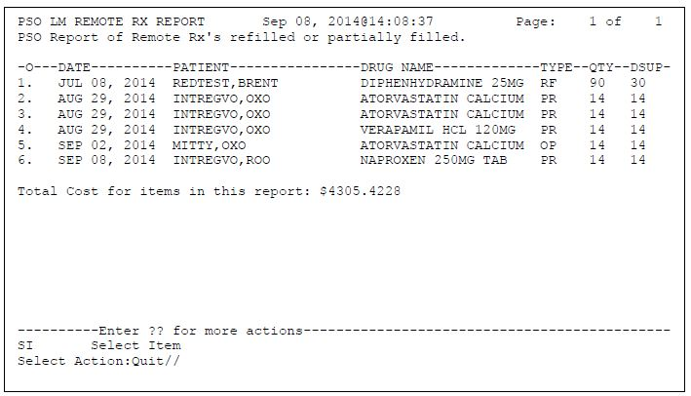

Figure 4: Remote Report Content Example

##### Our prescriptions, filled by other facilities

There are three search options available for the ‘Our prescriptions, filled by other facilities’ report. They are:

1. D: Date Range
2. P: Patient
3. S: Site

When selecting ‘D: Date Range’ the user is prompted to enter a start date and end date. The system defaults to 30-days prior to current system date as the start date and the current date as the end date.

When selecting ‘P: Patient’ the user is prompted to specify the patient’s name, social securing number, last four digits of the social security number, or first initial of last name with the last four digits of the social security number.

When selecting ‘S: Site’ the user is promoted to enter a site name, status, station number, official VA name, current location, coding system/id pair, NPI, name (changed from), or coding system.

The following table lists the values displayed on the report.

Table 3: Our prescriptions, filled by other facilities

| Report Column | Data Source |
| --- | --- |
| DATE FILLED | REMOTE PRESCRIPTION LOG FILE (#52.09) – REFILL/PARTIAL DATE (.09) |
| PATEINT | REMOTE PRESCRIPTION LOG FILE (#52.09) – PATIENT (.02) |
| DRUG NAME | REMOTE PRESCRIPTION LOG FILE (#52.09) – LOCAL (MATCHED) DRUG (1.1) |
| TYPE | REMOTE PRESCRIPTION LOG FILE (#52.09) – REQUEST TYPE (.05) |
| QTY | REMOTE PRESCRIPTION LOG FILE (#52.09) – QUANTITY (0.7) |
| DSUP | REMOTE PRESCRIPTION LOG FILE (#52.09) – DAYS SUPPLY (.08) |

The following image displays the remote report example.



Figure 5: Remote Report Content Example

##### All Remote activity

There are three search options available for the ‘All Remote activity’ report. They are:

1. D: Date Range
2. P: Patient
3. S: Site

When selecting ‘D: Date Range’ the user is prompted to enter a start date and end date. The system defaults to 30-days prior to current system date as the start date and the current date as the end date.

When selecting ‘P: Patient’ the user is prompted to specify the patient’s name, social securing number, last four digits of the social security number, or first initial of last name with the last four digits of the social security number.

When selecting ‘S: Site’ the user is promoted to enter a site name, status, station number, official VA name, current location, coding system/id pair, NPI, name (changed from), or coding system.

The following table lists the values displayed on the report.

Table 4: All Remote Activity

| Report Column | Data Source |
| --- | --- |
| DATE FILLED | REMOTE PRESCRIPTION LOG FILE (#52.09) – REFILL/PARTIAL DATE (.09) |
| PATEINT | REMOTE PRESCRIPTION LOG FILE (#52.09) – PATIENT (.02) |
| DRUG NAME | REMOTE PRESCRIPTION LOG FILE (#52.09) – LOCAL (MATCHED) DRUG (1.1) |
| TYPE | REMOTE PRESCRIPTION LOG FILE (#52.09) – REQUEST TYPE (.05) |
| QTY | REMOTE PRESCRIPTION LOG FILE (#52.09) – QUANTITY (0.7) |
| DSUP | REMOTE PRESCRIPTION LOG FILE (#52.09) – DAYS SUPPLY (.08) |

The following image displays the remote report example.



Figure 6: Remote Report Content Example

#### Unmapped Data Element

Not applicable.

## Conceptual Infrastructure Design

The OneVA Pharmacy project uses the VAeMI ESB for calls to the HDR/CDS repository. The following diagram depicts the message flow through the system.



Figure 7: OneVA Pharmacy Components

### System Criticality and High Availability

The OneVA Pharmacy extends the VistA application and will incorporate by default the same rules of engagement as VistA.

### Special Technology

The OneVA Pharmacy engages the VAeMI-Middleware components and the HDR/CDS repository. They are:

* Integration Bus (IB) v9 – the ESB supplied by the VA
* HCP: Healthcare Connectivity Pack (HCP) – contains the HL7 API and other health-related software to run in the ESB, also supplied by VA
* Message Broker (MQ) – A message queue that will handle messages passed into the ESB, also supplied by VA

Table 5: Special Technology Requirements

| Special Technology | Description | Notional Location | TRM Status |
| --- | --- | --- | --- |
| Integration Bus (IB) v9 | IBM’s ESB supplied by the VA | Application Server | Yes |
| HCP: Healthcare Connectivity Pack (HCP) | Supports HL7 data flows | Integrated into the ESB | Yes |
| Message Broker (MQ) | IBM’s message queue that will handle messages passed into the ESB for reliable messaging | Application Server | Yes |

### Technology Locations

The OneVA Pharmacy software uses the existing VistA instances deployed in the VA Enterprise. There are no changes to the technology locations

The following table describes the technology components used and locations.

Table 6: Technology Components Used

|  |  |  |
| --- | --- | --- |
| **Technology Component** | **Location** | **Usage** |
| **Production 1** |  |  |
| Workstations | VA VistA Pharmacy | Pharmacists and support staff. |
| Special Hardware | None. |  |
| Interface Processors | Same as current. | Same as current. |
| Legacy Mainframe | None. |  |
| Legacy Application Server | Same as current | Same as current. |
| Legacy Databases | Same as current | Same as current |
| Other |  |  |

### Conceptual Infrastructure Diagram

#### Location of Environments and External Interfaces

The system shall use existing locations and existing VistA technology as noted in Technology Components Used Table.

#### Conceptual Production String Diagram

This is the Conceptual production string diagram that shows a broad overview of a production system. The Pharmacist will pull up a patient’s medication profile screen from a local VistA instance. A message will be routed to the HDR/CDS to retrieve the complete list of prescriptions active for a patient, regardless of where the prescription originated. The Pharmacist will fill the prescription sending the sending a message to the originating VistA instance to decrement the remaining balance and last fill date. Once the data is in the VistA Server it can be used to produce a report and shown in the following figure.

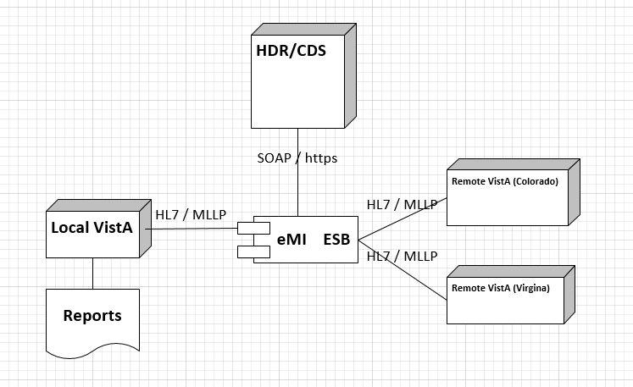

Figure 8: Conceptual Production String Diagram

# System Architecture

## Hardware Architecture

Not applicable.

## Software Architecture

### VAeMI ESB

The VAeMI ESB is responsible for message passing, routing and transformation. By utilizing several communication protocols and handing various message format, the VAeMI ESB is the backbone of the system. This system contains an MLLP Service to handle all incoming MLLP HL7 v2.x requests. The requests will be routed based on the message type and trigger event (MSH-10). The MLLP Service will route the following messages to the appropriate service:

Table 7: MLLP HL7 Endpoint Messages

| Message | Response | Description | Service Reference |
| --- | --- | --- | --- |
| QBP^Q13 | RTB^K13 | Query by parameter |  |
| RDS^O13 | RRD^O14 | Pharmacy/Treatment Dispense Message |  |

### HDR/CDS Endpoint

The VAeMI ESB will handle QBP-Q13 HL7 query requests to the HDR/CDS to retrieve a patient’s list of active prescriptions. The response will be in a XML SOAP format which will be transformed into an HL7 v2.x RTB-K13 message with tabular data containing aggregated, active prescription information in the remote VistAs.

The following diagram displays the HDR/CDS endpoints, which consist of several method calls that can be accessed from SOAP clients. The first method, readClinicalData, is the only method required by OneVA Pharmacy.

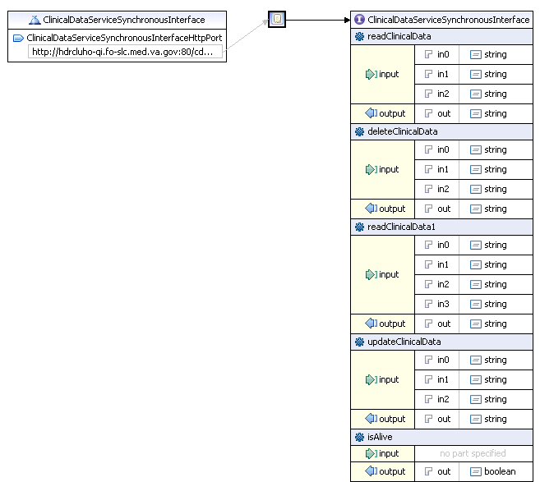

Figure 9: HDR Endpoint Methods and Parameters

The following imaged displays a template of the SOAP request and parameters.

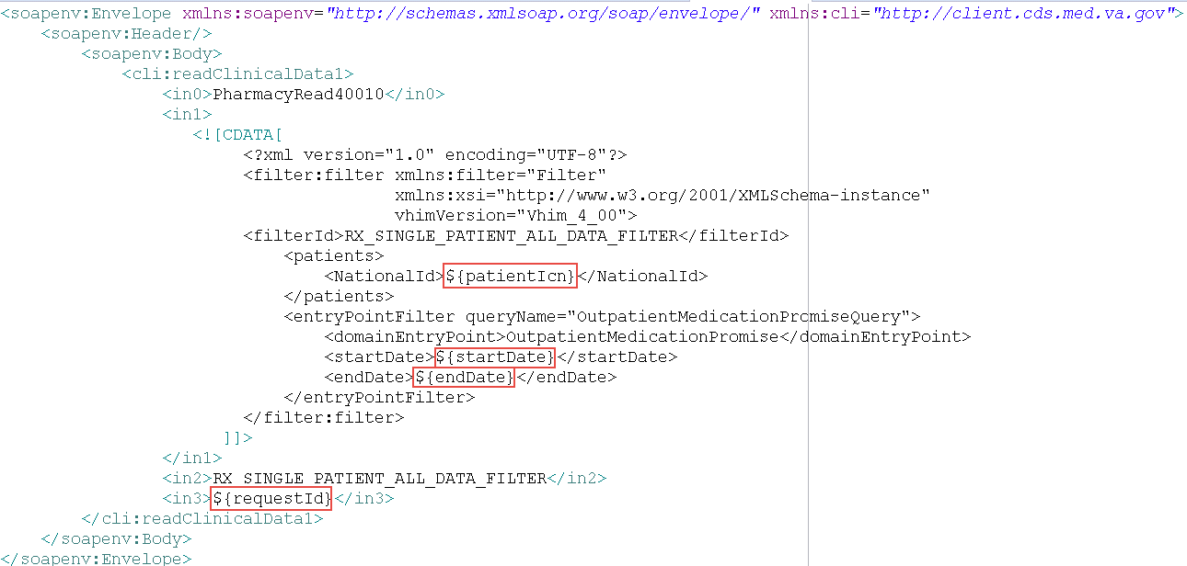

Figure 10: Template of the SOAP Request

The following is a list of parameters and their meaning:

* in0 – Static parameter
* in1 – “Filter” request to the HDR/CDS in order to process the request
* in2 – Static parameter
* in3 – Client-supplied request id in order to correlate requests and response for potentially asynchronous calls

The ‘in1’ parameter is fairly complex. The HDR/CDS has many clients with changing needs for querying patient information. In order to supply a single interface, the HDR/CDS employs a “filter” mechanism for some parameters. OneVA pharmacy will access one patient’s medical record profile. The HDR/CDS responds with an array of OutpatientMedicationPromises.

Table 8: Variables and Description

| **Variable** | **Description** |
| --- | --- |
| patientIcn | National Patient ID that exists across all VistA systems |
| startDate | Beginning date in which to retrieve a patient’s records. All records are required, therefore the startDate is hard-coded to January 1st, 1900 |
| endDate | End date will always be the current date |
| requestId | Client-supplied request id in order to correlate requests and responses for potentially asynchronous calls |

The following diagram provides the response structure from the HDR/CDS.

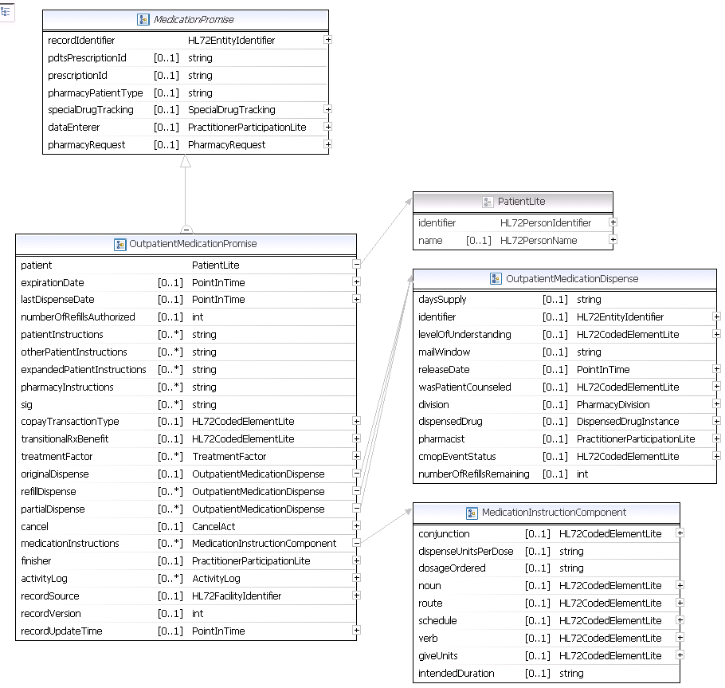

Figure 11: Diagram of the HDR/CDS Pharmacy.xsd’s OutpatientMedicationPromise

The diagram of the HDR/CDS xsd is only portion of the entire structure, relevant to OneVA Pharmacy. The xsd utilizes the concepts of inheritance and data types. The array of objects returned from the HDR/CDS will be transformed into the RTB^K13 HL7 message that is returned to the calling VistA.

### Sequence Diagrams

The next sub-sections show the sequence of events among key entities when the Use Cases are being executed.

#### View Order

The following figure displays a VistA instance querying the HDR/CDS (the local VistA system currently in use by the end user.) The local VistA is where the patient is physically located at the time the refill is requested that is not their normal VA facility. The provider will view all the active prescriptions via a request made to the HDR/CDS repository. The HDR/CDS repository contains all active prescriptions for this patient. The pharmacist will have the ability to view on the medication profile screen a list of both local and remote prescriptions for the patient.

| Use Case: View Orders |
| --- |
| The image displays the View Order Use Case Sequence Diagram |

Figure 12: View Order Sequence Diagram

#### Dispense Remote Order Sequence Diagram

Dispense Remote Order displays the sequence of events to fill a remote order. Similar to the View Order Use Case, an order was created for the patient at a remote VistA system. The pharmacist will be able to view all active prescriptions for the patient and can select an active prescription from a remote VistA to refill. Once selecting a remote prescription and executing the fill order request, the system will send a message to the VAeMI ESB, which will route the request to the originating VistA instance. This request will decrement the prescription count, but will not affect the inventory of the remote facility. When the decrement is successful, communication is made back to the local VistA instance to complete the dispense processing locally and print a prescription label.

| **Use Case: Dispense Remote Order** |
| --- |
| The image displays the Dispense Remote Order Sequence Diagram |

Figure 13: Dispense Remote Order Sequence Diagram

### Design Rationale

The basis of this project is to allow standalone VistA instances to route and transform messages and affect each other’s state, using the VAeMI-Middleware and integrating with the HDR/CDS repository.

### HL7 Protocol

The communication protocol used between components is HL7 v2. x. HL7 v2.x is a standard messaging protocol used to communicate among health information systems.

## Network Architecture



Figure 14: Network Architecture

## Service Oriented Architecture / ESS

The following diagram displays the VistA application and how it will exist within the design of the ESB model.



Figure 15: VistA and VAeMI ESB Integration

The entities displayed in the Application Architecture Diagram are explained as follows:

* VistA is the user interface for initiating prescription queries and requesting prescription refills from remote VistAs.
* VAeMI ESB is the messaging component to handle MLLP HL7 endpoints and the HDR/CDS.



Figure 16: HL7/MLLP and SOAP/https Integration

## Enterprise Architecture

The Enterprise Architecture of OneVA Pharmacy consists of three main components. They are:

1. VistA
2. VAeMI ESB (for communication)
3. HDR/CDS

To use an example to explain the architecture, a Pharmacist at one VA facility will use VistA to display all the prescriptions for a Veteran that originated at another VA facility. In order to display all of the active prescriptions the HDR/CDS will be used to accumulate all prescriptions. The local VistA instance will send an HL7 message to the VAeMI ESB. The VAeMI ESB will transform the HL7 message into a SOAP request over https to the HDR/CDS service endpoint. The SOAP response from the HDR/CDS is transformed into an RTB^K13 HL7 message and sent as a response to the calling VistA instance. The VistA instance will display the entire prescription record for the user. Once the Pharmacist selects a prescription from a remote VistA to refill a prescription, another message is generated and sent to the VAeMI ESB. The VAeMI ESB will detect that the message is a prescription fill request and then route the message to the destination VistA. The remote VistA instance receives the message on it’s logical link and performs the necessary decrement to the patient’s prescription refill allotment without affecting the remote facilities inventory.

# Data Design

## DBMS Files

### Refill Multiple (#52.1) of the Prescription File (#52)

| Field Number | Field Name | Pointers | Cross References and Record Indices | Description |
| --- | --- | --- | --- | --- |
| 91 | Remote Fill Site | Institution File (#4) | “RFIL” | This is the site that performed the remote refill action. |
| 92 | Remote Pharmacist | N/A | N/A | This is the name of the remote pharmacist that performed the refill action. |
| 93 | Remote Pharmacist Phone | N/A | N/A | This is the phone number for the pharmacist that performed the refill action. |

### Partial Multiple (#52.2) of the Prescription File (#52)

| Field Number | Field Name | Pointers | Cross References and Record Indices | Description |
| --- | --- | --- | --- | --- |
| 91 | Remote Fill Site | Institution File (#4) | “RFIL” | This is the site that performed the remote partial fill action. |
| 92 | Remote Pharmacist | N/A | N/A | This is the name of the remote pharmacist that performed the partial fill action. |
| 93 | Remote Pharmacist Phone | N/A | N/A | This is the phone number for the pharmacist that performed the partial fill action. |

### Remote Prescription Log (#52.09)

| Field Number | Field Name | Pointers | Cross References and Record Indices | Description |
| --- | --- | --- | --- | --- |
| .01 | LOG DATE/TIME | N/A | 52.09^B | Date/Time of refill/partial fill transaction. |
| .02 | PATIENT | PATIENT (#2) | 52.09^C | This is the patient for which a refill or partial fill was executed remotely. |
| .03 | RX NUMBER | N/A | 52.9^D | This is the RX Number from the prescription file (#52). ** Should this be converted to a pointer??** |
| .04 | SITE NUMBER | INSTITUTION (#4) | 5209^E |  |
| .05 | REQUEST TYPE | N/A |  | RF – REFILL  PR – PARTIAL FILL  OR – OUTSIDE REFILL  OP – OUTSIDE PARTIAL FILL |
| .06 | OUTGOING REQUEST PHARMACIST | NEW PERSON (#200) | N/A | This is the pharmacist who initiated the refill or partial fill request to the remote facility |
| .061 | REMOTE FILLING PHARMACIST | N/A | N/A | This is the pharmacist that requested a refill or partial fill from a remote facility. |
| .07 | QUANTITY | N/A | N/A | This is the quantity dispensed. |
| .08 | DAYS SUPPLY | N/A | N/A | This is the day’s supply for the medication. |
| .09 | REFILL/PARTIAL DATE | N/A | N/A | This is the date of the refill or partial fill request. This represents the date as it is logged in the .01 field of either the refill or partial sub files within the prescription file. |
| .1 | DISPENSED DATE | N/A | N/A | This is the Dispense date as it is held in the DISPENSED DATE within the REFILL or PARTIAL sub files of the PRESCRIPTION file. |
| 1 | REMOTE DRUG NAME | N/A | N/A | This is the name of the drug being dispensed for this request.** Note, we may want both the name and VA product id..*** |
| 1.1 | LOCAL (MATCHED) DRUG | DRUG (#50) | N/A | This is the drug that was used locally for the ‘remote’ refill or partial fill. |
| 1.2 | TOTAL REFILL/PARTIAL FILL COST | N/A | N/A | This is the total cost for the ‘remote’/filling facility. The cost is derived by using the cost of the drug at the time of the refill or partial fill. The cost is being retrieved from file 50, field 13. |
| 2 | MESSAGE DETAILS | N/A | N/A | Any message details related to the transaction. |
| 3 | LABEL DATA | N/A | N/A | Label data word processing field. |

## Non-DBMS Files

Not applicable.

## Data View

Not applicable.

# Detailed Design

## Hardware Detailed Design

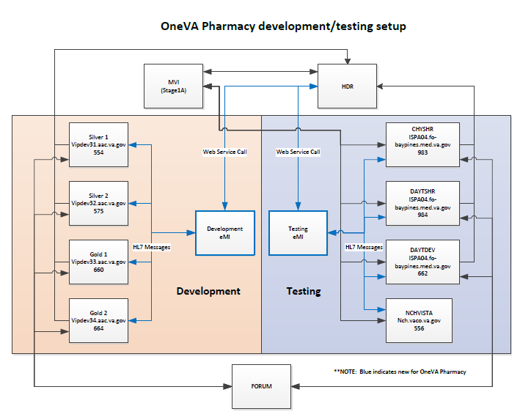

Figure 17: Hardware Detailed Design

## Software Detailed Design

### Conceptual Design



Figure 18: Conceptual Design

#### Product Perspective

The OneVA Pharmacy extends the existing VistA, specifically Patient Prescription Processing [PSO LM BACKDOOR ORDERS] to provide pharmacists direct access to any active, refillable prescription from any VA Healthcare System.

##### User Interfaces

The OneVA Pharmacy extends the existing VistA application so the user interface is the VistA [PSO LM BACKDOOR ORDERS].

##### Hardware Interfaces

The hardware interface will utilize the existing architecture found within the VA Enterprise.

##### Software Interfaces

The software interfaces by

##### Communications Interfaces



Figure 19: Communications Interface

The services within the VAeMI ESB are logical capabilities the ESB is expected to perform. The actual service names may be different due to the VAeMI team’s implementation.

##### Memory Constraints

Not applicable.

##### Special Operations

Not applicable.

#### Product Features

The OneVA Pharmacy Implementation at a high level includes:

* VistA Patch PSO*7*454
  + PSO LM BACKDOOR ORDERS
* VAeMI-Middleware
* Connectivity to the Health Data Repository/ Clinical Data Services (HDR/CDS) via the Enterprise Service Bus (VAeMI)
* Validation of Health Level 7 (HL7) messages

#### User Characteristics

The user profile of the OneVA Pharmacy module are those users, specifically pharmacists, that use the Pharmacy [PSO LM BACKDOOR ORDERS] menu to dispense prescriptions.

#### Dependencies and Constraints

The OneVA Pharmacy implementation is dependent upon the availability of the VAeMI ESB and its connectivity to the HDR/CDS repository and all 130 VistA instances where Pharmacy locations are included.

### Specific Requirements

#### Database Repository

Not applicable.

#### System Features

The system features include functional requirements, sub-requirements, business rules, design constraints, etc. and are organized in a Requirements Specification Document (RSD). The OneVA Pharmacy RSD, located on the VA SharePoint. The OneVA Pharmacy RSD can be access by following this LINK.

#### Design Element Tables

Not applicable.

##### Routines (Entry Points)

###### PSOORNE2

The ‘PSOORNE2’ routine has been modified to include the display of the remote prescriptions. This routine will display the details related to the remote Rx that has been selected.

Table 15 (Grouping): Routines

| Routines | Activities | | | |
| --- | --- | --- | --- | --- |
| **Routine Name** | PSOORNE2 | | | |
| **Enhancement Category** | New | Modify | Delete | No Change |
| **RTM** |  | | | |
| **Related Options** | PSO LM BACKDOOR ORDERS | | | |

| Related Routines | Routines “Called By” | Routines “Called” |
| --- | --- | --- |
|  | PSODISPS, PSOLMUTL, PSOMPHRC, PSOORCPY, PSOOREDT, PSOREF, PSORREF, PSORXEDT | PSOORNE6, PSOVER1, PSORRX1, PSOBUILD, PSOORUT1, PSODRG, PSOORNE5, PSONFI, PSOBPSUT, PSOHELP, PSOUTLA2, PSOORNE3, PSODAWUT, PSSDAWUT, PSOLMLST, PSOROS |

| Routines | Activities | | | | |
| --- | --- | --- | --- | --- | --- |
| **Data Dictionary (DD) References** | ^PSDRUG(  ^YSCL(603.01,  ^PS(50.606,  ^PS(50.7,  ^PS(52.5  ^PSRX(  ^DIC(4, | | | | |
| **Related Protocols** | N/A | | | | |
| **Related Integration Control Registrations (ICRs)** | 4708 – Call to DAWEXT^PSSDAWUT (Active/Controlled Subscription) | | | | |
| **Data Passing** | Input | Output Reference | Both | Global Reference | Local |
| **Input Attribute Name and Definition** | Name: N/A  Definition: | | | | |
| **Output Attribute Name and Definition** | Name: N/A  Definition: | | | | |

| Current Logic |
| --- |
| Cannot get current logic until we have all patches associated with this routine. |

| Modified Logic (Changes are in bold) |
| --- |
|  |

###### PSOORUT1

The ‘PSOORUT1’ routine has been modified to include the display of remote prescriptions within the [PSO LM BACKDOOR ORDER] prescription list. The prescriptions are sorted by facility and include the same display elements at eh local prescription. Each remote facility’s prescription list has a programmatically generated header that separates the prescriptions by status (Active, Suspended, Hold, etc.)

| Routines | Activities | | | |
| --- | --- | --- | --- | --- |
| **Routine Name** | PSOORUT1 | | | |
| **Enhancement Category** | New | Modify | Delete | No Change |
| **RTM** |  | | | |
| **Related Options** | PSO LM BACKDOOR ORDERS | | | |

| Related Routines | Routines “Called By” | Routines “Called” |
| --- | --- | --- |
|  | PSOCAN4, PSODISP3, PSOHLNEW, PSOLMUTL, PSONEW, PSOORFI2, PSOORFL, PSOORNE2, PSOORUTL, PSOREF, PSORENW4, PSORX1, PSOTPRX1, PSOVER | %DTC,DICN, DIK, DIQ, PSOBPSU1, PSOBPSUT, PSOHLSN1,PSOORUTL, PSOREJUT, PSOUTL, |

| Routines | Activities | | | | |
| --- | --- | --- | --- | --- | --- |
| **Data Dictionary (DD) References** | ^PS(52.41,  ^PSRX(  ^PS(52.5,  ^DIC(4, | | | | |
| **Related Protocols** |  | | | | |
| **Related Integration Control Registrations (ICRs)** | IA #221 – Access to ^PSDRUG  IA #2203 – Call to ^PSXOPUTL | | | | |
| **Data Passing** | Input | Output Reference | Both | Global Reference | Local |
| **Input Attribute Name and Definition** | Name: N/A  Definition: N/A | | | | |
| **Output Attribute Name and Definition** | Name: N/A  Definition: N/A | | | | |

| Current Logic |
| --- |
| Cannot get current logic until we have all patches associated with this routine. |

| Modified Logic (Changes are in bold) |
| --- |
|  |

###### PSOROS

The ‘PSOROS’ routine is the driving routine for selection of a ‘remote’ prescription within list manager. This routine controls the list template [PSO LM REMOTE ORDER SELECTION].

| Routines | Activities | | | |
| --- | --- | --- | --- | --- |
| **Routine Name** | PSOROS | | | |
| **Enhancement Category** | New | Modify | Delete | No Change |
| **RTM** |  | | | |
| **Related Options** |  | | | |

| Related Routines | Routines “Called By” | Routines “Called” |
| --- | --- | --- |
|  |  | VALM, PSONFI, XQORM1 |

| Routines | Activities | | | | |
| --- | --- | --- | --- | --- | --- |
| **Data Dictionary (DD) References** |  | | | | |
| **Related Protocols** | PSO LM REMOTE ORDER MENU  PSO LM REFILL REMOTE ORDER  PSO LM REMOTE PARTIAL | | | | |
| **Related Integration Control Registrations (ICRs)** | N/A | | | | |
| **Data Passing** | Input | Output Reference | Both | Global Reference | Local |
| **Input Attribute Name and Definition** | Name: N/A  Definition: N/A | | | | |
| **Output Attribute Name and Definition** | Name: N/A  Definition: N/A | | | | |

| Current Logic |
| --- |
| N/A |

|  |  |  |  |  |  |  |  |  |  |  |  |  |  |  |  |  |  |  |  |  |  |  |  |  |  |  |  |
| --- | --- | --- | --- | --- | --- | --- | --- | --- | --- | --- | --- | --- | --- | --- | --- | --- | --- | --- | --- | --- | --- | --- | --- | --- | --- | --- | --- |
| | Modified Logic (Changes are in bold) | | --- | |  |  PSORRD The ‘PSORRD’ routine is the routine that controls the PSO LM REMOTE REPORTS DETAILS list manager template. This routine is part of the Remote Prescription Report functionality.   | Routines | Activities | | | | | --- | --- | --- | --- | --- | | **Routine Name** | PSORRD | | | | | **Enhancement Category** | New | Modify | Delete | No Change | | **RTM** |  | | | | | **Related Options** |  | | | | |

| Related Routines | Routines “Called By” | Routines “Called” |
| --- | --- | --- |
|  |  | VALM, XQORM1 |

| Routines | Activities | | | | |
| --- | --- | --- | --- | --- | --- |
| **Data Dictionary (DD) References** | N/A | | | | |
| **Related Protocols** | N/A | | | | |
| **Related Integration Control Registrations (ICRs)** | N/A | | | | |
| **Data Passing** | Input | Output Reference | Both | Global Reference | Local |
| **Input Attribute Name and Definition** | Name:  Definition: | | | | |
| **Output Attribute Name and Definition** | Name:  Definition: | | | | |

| Current Logic |
| --- |
| N/A |

|  |  |  |  |  |  |  |
| --- | --- | --- | --- | --- | --- | --- |
| | Modified Logic (Changes are in bold) | | --- | |  |  PSORREF The ‘PSORREF’ routine is the main driving routine for the ‘receiving’ or ‘originating’ facility to process incoming refill requests. | | | | |
| Routines | Activities | | | |
| **Routine Name** | PSORREF | | | |
| **Enhancement Category** | New | Modify | Delete | No Change |
| **RTM** |  | | | |
| **Related Options** | PSO LM BACKDOOR ORDERS | | | |

| Related Routines | Routines “Called By” | Routines “Called” |
| --- | --- | --- |
|  |  | %DTC, %ZISH, DIE, DIQ, PSOBUILD, PSOCPTRI, PSOREJU1, PSORREF0, PSORREF1, PSORRX1, PSSLOCK, XLFDT, XUAF4 |

| Routines | Activities | | | | |
| --- | --- | --- | --- | --- | --- |
| **Data Dictionary (DD) References** | ^PSRX(  %ZIS(1,  ^PS(55, | | | | |
| **Related Protocols** | N/A | | | | |
| **Related Integration Control Registrations (ICRs)** | Need to see if we need any IA’s | | | | |
| **Data Passing** | Input | Output Reference | Both | Global Reference | Local |
| **Input Attribute Name and Definition** | Name: RXNUM  Definition: Prescription Number  Name: FDATE  Definition: Fill Date  Name: MW  Definition: Mail/Window  Name: RPHARM  Definition: Remote Pharmacists Name  Name: RPHONE  Definition: Remote Pharmacists Telephone Number  Name: RISTE  Definition: Remote site requesting the refill | | | | |
| **Output Attribute Name and Definition** | Name: RET  Definition: Return array “Rx # xxxxx refilled.”, or error message. | | | | |

| Current Logic |
| --- |
| N/A |

|  |  |  |  |  |  |  |
| --- | --- | --- | --- | --- | --- | --- |
| | Modified Logic (Changes are in bold) | | --- | |  |  PSORREF0 The ‘PSORREF0’ is a supporting routine to ‘PSORREF’. | | | | |
| Routines | Activities | | | |
| **Routine Name** | PSORREF0 | | | |
| **Enhancement Category** | New | Modify | Delete | No Change |
| **RTM** |  | | | |
| **Related Options** | PSO LM BACKDOOR ORDERS | | | |

| Related Routines | Routines “Called By” | Routines “Called” |
| --- | --- | --- |
|  | PSORREF1 | %DT, DIR, PSOPTPST, PSOR52, PSOREF1, PSOREF2, PSOUTIL, PSOUTLA, PSOUTLA1, VALM1 |

| Routines | Activities | | | | |
| --- | --- | --- | --- | --- | --- |
| **Data Dictionary (DD) References** | ^PSRX | | | | |
| **Related Protocols** |  | | | | |
| **Related Integration Control Registrations (ICRs)** | Will need to get included in IA 221 | | | | |
| **Data Passing** | Input | Output Reference | Both | Global Reference | Local |
| **Input Attribute Name and Definition** | Name:  Definition: | | | | |
| **Output Attribute Name and Definition** | Name: PSORMSG  Definition: Output message containing information about the refill request. | | | | |

| Current Logic |
| --- |
| N/A |

|  |  |  |  |  |  |  |
| --- | --- | --- | --- | --- | --- | --- |
| | Modified Logic (Changes are in bold) | | --- | |  |  PSORREF1 The ‘PSORREF1’ is a supporting routine for ‘PSORREF’. | | | | |
| Routines | Activities | | | |
| **Routine Name** | PSORREF1 | | | |
| **Enhancement Category** | New | Modify | Delete | No Change |
| **RTM** |  | | | |
| **Related Options** | PSO LM BACKDOOR ORDERS | | | |

| Related Routines | Routines “Called By” | Routines “Called” |
| --- | --- | --- |
|  | PSORREF | %DT |

| Routines | Activities | | | | |
| --- | --- | --- | --- | --- | --- |
| **Data Dictionary (DD) References** | ^PSRX | | | | |
| **Related Protocols** | N/A | | | | |
| **Related Integration Control Registrations (ICRs)** | N/A | | | | |
| **Data Passing** | Input | Output Reference | Both | Global Reference | Local |
| **Input Attribute Name and Definition** | N/A | | | | |
| **Output Attribute Name and Definition** | N/A | | | | |

| Current Logic |
| --- |
| N/A |

|  |  |  |  |  |  |  |
| --- | --- | --- | --- | --- | --- | --- |
| | Modified Logic (Changes are in bold) | | --- | |  |  PSORRP The ‘PSORRP’ routine assists in prompting for search criteria and display of the Remote Prescription Report. | | | | |
| Routines | Activities | | | |
| **Routine Name** | PSORRP | | | |
| **Enhancement Category** | New | Modify | Delete | No Change |
| **RTM** |  | | | |
| **Related Options** | PSO REMOTE RX REPORT | | | |

| Related Routines | Routines “Called By” | Routines “Called” |
| --- | --- | --- |
|  | N/A | %DT, DIC, DIQ, DIR, PSOROS, PSORRD, VALM, VALM1, VALM10, XLFDT, XQORM1 |

| Routines | Activities | | | | |
| --- | --- | --- | --- | --- | --- |
| **Data Dictionary (DD) References** | ^PSRXR(52.09, | | | | |
| **Related Protocols** |  | | | | |
| **Related Integration Control Registrations (ICRs)** | N/A | | | | |
| **Data Passing** | Input | Output Reference | Both | Global Reference | Local |
| **Input Attribute Name and Definition** | N/A | | | | |
| **Output Attribute Name and Definition** | N/A | | | | |

| Current Logic |
| --- |
| N/A |

|  |  |  |  |  |  |  |
| --- | --- | --- | --- | --- | --- | --- |
| | Modified Logic (Changes are in bold) | | --- | |  |  PSORRPA1 The ‘PSORRPA1’ is the main routine for processing an incoming partial fill request. | | | | |
| Routines | Activities | | | |
| **Routine Name** | PSORRPA1 | | | |
| **Enhancement Category** | New | Modify | Delete | No Change |
| **RTM** |  | | | |
| **Related Options** | PSO LM BACKDOOR ORDERS | | | |

| Related Routines | Routines “Called By” | Routines “Called” |
| --- | --- | --- |
|  | N/A | %ZISH, DIE, DIK, DIQ, PSOBPSUT, PSOCAN3, PSOCPTRI, PSOHLSN1, PSORRX1, PSORXL1, PSSLOCK, VADPT, XLFDT, XUAF4 |

| Routines | Activities | | | | |
| --- | --- | --- | --- | --- | --- |
| **Data Dictionary (DD) References** | ^PSRX(  ^PS(59,  ^PS(52.5,  ^%ZIS(1,  ^PS(55, | | | | |
| **Related Protocols** |  | | | | |
| **Related Integration Control Registrations (ICRs)** | IA 221?  IA 999?? | | | | |
| **Data Passing** | Input | Output Reference | Both | Global Reference | Local |
| **Input Attribute Name and Definition** | Name: RXNUM  Definition:  Name: PFDATE  Definition: Partial fill date  Name: MW  Definition: Mail/Window  Name: QTY  Definition: Quantity  Name: DSUPP  Definition: Days supply  Name: REMARKS  Definition: Remarks (if applicable)  Name: PHARM  Definition: Name of Filling pharmacist (remote)  Name: PHONE  Definition: Phone number of remote pharmacist  Name: SITE  Definition: Remote Site number | | | | |
| **Output Attribute Name and Definition** | Name: VALMSG  Definition: Response message for partial fill | | | | |

| Current Logic |
| --- |
| N/A |

|  |  |  |  |  |  |  |
| --- | --- | --- | --- | --- | --- | --- |
| | Modified Logic (Changes are in bold) | | --- | |  |  PSORRX1 The ‘PSORRX1’ routine builds the HL7 messages that are sent to the Pharmacy Remote Prescription Manager to retrieve, refill, and partial fill prescriptions from another facility. This routine uses the treating facility list to properly build the HL7 information to send to the ‘remote’ site(s). | | | | |
| Routines | Activities | | | |
| **Routine Name** | PSORRX1 | | | |
| **Enhancement Category** | New | Modify | Delete | No Change |
| **RTM** |  | | | |
| **Related Options** | PSO LM BACKDOOR ORDERS | | | |

| Related Routines | Routines “Called By” | Routines “Called” |
| --- | --- | --- |
|  | PSORX1 | %ZIS, DIC, DIE, DILFD, DIQ, DIR, HLFNC2, HLMA, PSODIR2, VAFCTFU2, VALM1, XLFDT, XUAF4 |

| Routines | Activities | | | | |
| --- | --- | --- | --- | --- | --- |
| **Data Dictionary (DD) References** |  | | | | |
| **Related Protocols** |  | | | | |
| **Related Integration Control Registrations (ICRs)** |  | | | | |
| **Data Passing** | Input | Output Reference | Both | Global Reference | Local |
| **Input Attribute Name and Definition** | Name: DFN  Definition: Patients local IEN | | | | |
| **Output Attribute Name and Definition** | HL7 MESSAGE IN HL7 QUEUE | | | | |

| Current Logic |
| --- |
| N/A |

|  |  |  |  |  |  |  |
| --- | --- | --- | --- | --- | --- | --- |
| | Modified Logic (Changes are in bold) | | --- | |  |  PSORWRAP The ‘PSORWRAP’ routine is the wrapper utility for the calls into VistA. | | | | |
| Routines | Activities | | | |
| **Routine Name** | PSORWRAP | | | |
| **Enhancement Category** | New | Modify | Delete | No Change |
| **RTM** |  | | | |
| **Related Options** | N/A | | | |

| Related Routines | Routines “Called By” | Routines “Called” |
| --- | --- | --- |
|  | N/A | PSORREF, PSORRPA1, XLFDT, XUP |

| Routines | Activities | | | | |
| --- | --- | --- | --- | --- | --- |
| **Data Dictionary (DD) References** | N/A | | | | |
| **Related Protocols** | N/A | | | | |
| **Related Integration Control Registrations (ICRs)** | N/A | | | | |
| **Data Passing** | Input | Output Reference | Both | Global Reference | Local |
| **Input Attribute Name and Definition** | Name: QBSESSID  Definition: Session ID  Name: QBDUZ  Definition: Users DUZ value | | | | |
| **Output Attribute Name and Definition** | Name: Status  Definition: returns session id and 1 if successful | | | | |

| Current Logic |
| --- |
| N/A |

|  |  |  |  |  |  |  |
| --- | --- | --- | --- | --- | --- | --- |
| | Modified Logic (Changes are in bold) | | --- | |  |  PSORX1 The ‘PSORX1’ routine has been modified to call ‘PSORRX1’ for retrieval of remote prescription data. | | | | |
| Routines | Activities | | | |
| **Routine Name** | PSORX1 | | | |
| **Enhancement Category** | New | Modify | Delete | No Change |
| **RTM** |  | | | |
| **Related Options** |  | | | |

| Related Routines | Routines “Called By” | Routines “Called” |
| --- | --- | --- |
|  |  | DTC, $ZISS, DGPFAPI, DIC, DICN, DIE, DIK, DIQ1, DIR, ORRDI1, PSOBAI, PSOBING, PSOBUILD, PSODDPR2, PSODEM, PSOHLUP, PSOLMAO, PSOLMUTL, PSOLSET, PSOORFI2, PSOORUT1, PSOORUT2, PSOPATLK, PSOPTPST, PSORMRX, PSORRX1, PSORXL, PSOSUPOE, PSUHL, VADPT, VALM1 |

| Routines | Activities | | | | |
| --- | --- | --- | --- | --- | --- |
| **Data Dictionary (DD) References** | ^PS(55,  ^DIC(31,  ^DPT(DO,.372,  ^XTMP(“ORRDI”  ^PSUHL  ^PSRX | | | | |
| **Related Protocols** | N/A | | | | |
| **Related Integration Control Registrations (ICRs)** | External reference ^PS(55 supported by DBIA 2228  External reference ^DIC(31 supported by DBIA 658  external reference ^DPT(D0,.372 supported by DBIA 1476  External reference DISPPRF^DGPFAPI supported by DBIA #4563  External reference ^ORRDI1 is supported by DBIA 4659  External reference ^XTMP("ORRDI" is supported by DBIA 4660  External reference ^PSUHL supported by DBIA 4803 | | | | |
| **Data Passing** | Input | Output Reference | Both | Global Reference | Local |
| **Input Attribute Name and Definition** | N/A | | | | |
| **Output Attribute Name and Definition** | N/A | | | | |

| Current Logic |
| --- |
| Cannot get current logic until we have all patches associated with this routine. |

|  |  |  |
| --- | --- | --- |
| | Modified Logic (Changes are in bold) | | --- | |  | |

##### Templates

###### PSO LM REMOTE ORDER SELECTION

The ‘PSO LM REMOTE ORDER SELECTION’ provides the logic needed to display a remote prescription within PSO LM BACKDOOR ORDERS.

| Templates | Description | | | |
| --- | --- | --- | --- | --- |
| **Template Name** | PSO LM REMOTE ORDER SELECTION | | | |
| **Enhancement Category** | New | Modify | Delete | No Change |
| **RSD** |  | | | |
| **Template Type** | Sort | Input | Print | Other |
| **Related Options** |  | | | |

| **Related Routines** | **Routines “Called By”** | **Routines “Called”** |
| --- | --- | --- |
|  | ^VALM |  |

| Routines | Description |
| --- | --- |
| **Data Dictionary (DD) References** | N/A |
| **Global References** |  |

PSO LM REMOTE REPORT DETAILS

The ‘PSO LM REMOTE REPORT DETAILS’ provides the logic that will display details about the remote report item.

| Templates | Description | | | |
| --- | --- | --- | --- | --- |
| **Template Name** | PSO LM REMOTE REPORT DETAILS | | | |
| **Enhancement Category** | New | Modify | Delete | No Change |
| **RSD** |  | | | |
| **Template Type** | Sort | Input | Print | Other |
| **Related Options** |  | | | |

| **Related Routines** | **Routines “Called By”** | **Routines “Called”** |
| --- | --- | --- |
|  |  |  |

| Routines | Description |
| --- | --- |
| **Data Dictionary (DD) References** | N/A |
| **Global References** |  |

PSO LM REMOTE RX REPORT

The ‘PSO LM REMOTE RS REPORT’ is the menu system for the selected items of the remote prescription report.

| Templates | Description | | | |
| --- | --- | --- | --- | --- |
| **Template Name** | PSO LM REMOTE RX REPORT | | | |
| **Enhancement Category** | New | Modify | Delete | No Change |
| **RSD** |  | | | |
| **Template Type** | Sort | Input | Print | Other |
| **Related Options** |  | | | |

| **Related Routines** | **Routines “Called By”** | **Routines “Called”** |
| --- | --- | --- |
|  |  |  |

| Routines | Description |
| --- | --- |
| **Data Dictionary (DD) References** | N/A |
| **Global References** |  |

##### Bulletins

Not applicable.

##### Data Entries Affected by the Design

Not applicable.

##### Unique Record(s)

Not applicable.

##### File or Global Size Changes

###### Global

The Pharmacy Remote Prescription Manager uses the following globals:

^PSRX

^PSRXR

The ^PSRX global holds the prescription data. The ^PSRXR global holds a comprehensive list of information regarding remote refill and partial fill activity.

Table 9: Global Placement and Protection

|  |  |  |  |  |
| --- | --- | --- | --- | --- |
| Global | Type | Placement | Journal | Protection |
| ^PSRX | Dynamic | No changes should be made to the current placement or settings related to this global | No change | No change |
| ^PSRXR | Static | Place this global in a volume set that can accommodate the following yearly growth rate: 2,000 bytes * visits per year | Yes | RWP or D |

###### Files

Table 10: Files

| File # | File Name | Root Global | Global Protection |
| --- | --- | --- | --- |
| 52 | PRESCRIPTION | ^PSRX | No change |
| 52.09 | REMOTE PRESCRIPTION LOG | ^PSRXR(52.09 | @ |

Prescription (#52) File

The overall prescription file definition remains unchanged, however there are a few modifications that track information related to a remote refill or partial fill. Those changes are listed in the following tables and are isolated to the sub-files for refill and partial fill.

REFILL Sub File (#52.1)

Table 11: REFILL Sub file (#52.1)

| Field Number | Field Name | Pointers | Cross References and Record Indices | Description |
| --- | --- | --- | --- | --- |
| 91 | REMOTE FILL SITE | Pointer to the Institution file (#4) | 52^RFIL | Pointer field: Points to the Institution from which the refill or partial fill request was generated. |
| 92 | REMOTE PHARMACIST | N/A | N/A | Free-text field: This free text field holds the name of the remote requesting pharmacist. This is the pharmacist that made the remote refill or partial fill request. |
| 93 | REMOTE PHARMACIST PHONE | N/A | N/A | Free-text field: This is the contact number for the remote (requesting) pharmacist. This is the pharmacist that initiated the remote refill or partial fill request. |

PARTIAL FILL Sub file (#52.2)

Table 12: PARTIAL FILL sub file (#52.2)

| Field Number | Field Name | Pointers | Cross References and Record Indices | Description |
| --- | --- | --- | --- | --- |
| 91 | REMOTE FILL SITE | Pointer to the Institution file (#4) | 52^PFIL | Pointer field: Points to the Institution from which the refill or partial fill request was generated. |
| 92 | REMOTE PHARMACIST | N/A | N/A | Free-text field: This free text field holds the name of the remote requesting pharmacist. This is the pharmacist that made the remote refill or partial fill request. |
| 93 | REMOTE PHARMACIST PHONE | N/A | N/A | Free-text field: This is the contact number for the remote (requesting) pharmacist. This is the pharmacist that initiated the remote refill or partial fill request. |

Remote Prescription Log (#52.09) File

Table 13: Remote Prescription Log (#52.09

| Field Number | Field Name | Pointers | Cross References and Record Indices | Description |
| --- | --- | --- | --- | --- |
| .01 | LOG DATE/TIME | N/A | 52.09^B | Date/Time (required): This is the date/time of the refill or partial fill activity. |
| .02 | PATIENT | Pointer to the PATIENT file (#2) | 52.09^C | Pointer field (required): This is the pointer to the patient file, which identifies what patient the refill or partial refill request is for. |
| .03 | RX NUMBER | N/A | 52.09^D | Free Text (required): This is the prescription number as it exists at the ‘originating’ facility. |
| .04 | SITE NUMBER | Pointer to the INSTITUTION file (#4) | 52.09^E | Pointer field (required): This is the pointer that identifies which facility was the ‘originating’ facility for this refill or partial fill request. |
| .05 | REQUEST TYPE | N/A |  | Set of codes: RF for REFILL (outgoing)  PR for PARTIAL FILL (outgoing)  OR for OUTSIDE REFILL (incoming)  OP for OUTSIDE PARTIAL FILL (incoming) |
| .06 | OUTGOING REQUEST PHARMACIST | Pointer to the NEW PERSON file (#200) |  | Pointer field (required): This is the pointer to the person who initiated a refill or partial fill request to a remote facility. |
| .07 | REMOTE FILLING PHARMACIST | N/A | N/A | Free Text: This is the textual name of the pharmacist who is requesting a refill or partial fill from a remote facility. This field is used to log ‘incoming’ refill and partial fill pharmacist data. |
| .07 | QUANTITY | N/A | N/A | Numeric: This is the quantity associated with the remote refill or partial fill. |
| .08 | DAYS SUPPLY | N/A | N/A | Numeric: This is the day’s supply associated with the remote fill or partial fill request. |
| .09 | REFILL/PARTIAL DATE | N/A | N/A | Date: This is the date for the refill or partial fill request. This represents the date as it is logged in the .01 field of either the REFILL (#52.1) or PARTAIL DATE (#52.2) sub file within the PRESCRIPTION file (#52). |
| .1 | DISPENSED DATE | N/A | N/A | Date: This is the date that the remote prescription request was dispensed. |
| 1 | REMOTE DRUG NAME | N/A | N/A | Free Text: This is the textual value for the remote drug. |
| 1.1 | LOCAL (MATCHED) DRUG | Pointer to the DRUG file (#50) | N/A | Pointer to the DRUG file (#50). This holds the locally identified drug that is equivalent to the drug name that is received from the remote (originating) facility. |
| 1.2 | TOTAL REFILL/PARTIAL COST | N/A | N/A | Numeric: This field is used to store the total cost for the refill or partial fill request. This value is based on the current cost of the drug, multiplied by the quantity. |
| 2 | MESSAGE DETAILS | N/A | N/A | Word-processing: This is where any additional message details are stored. |
| 3 | LABEL DATA | N/A | N/A | Word-processing: Once label data has been received from the originating facility, it is stored here for future reference and reprint. |

##### Mail Groups

Not applicable.

##### Security Keys

Not applicable.

##### Options

###### Pharmacy Remote Prescription Manager Options

| Name | Type | Description |
| --- | --- | --- |
| PSO LM BACKDOOR ORDERS | Menu |  |
| PSO RX | Menu | The overarching menu in which PSO REMOTE RX REPORT is contained. |
| PSO REMOTE RX REPORT | Run Routine | This option provides details about remote refill and partial fill request, as well as incoming refill and partial fill requests. |

PSO LM BACKDOOR ORDERS Option

| Options | Activities | | | | | | | | | | |
| --- | --- | --- | --- | --- | --- | --- | --- | --- | --- | --- | --- |
| **Option Name** | PSO LM BACKDOOR ORDERS | | | | | | | | | | |
| **Enhancement Category** | New | Modify | | | | Delete | | | No Change | | |
| **Associated Menu Options that will invoke this reference** |  | | | | | | | | | | |
| **Data Passing** | Input | | Output | | Both | | | Global Reference | | | Local Reference |
| **Menu Text Description** |  | | | | | | | | | | |
| **Option Type** | Edit | | | Print | | | Menu | | | Inquire | |
| Action | | | Run Routine | | | Other | | |  | |
| **Associated Routine** |  | | | | | | | | | | |
| **Option Definition** |  | | | | | | | | | | |

| Current Entry Action Logic |
| --- |
|  |

| Modified Entry Action Logic (Changes are in bold) |
| --- |
|  |

| Current Exit Action Logic |
| --- |
|  |

| Modified Exit Action Logic (Changes are in bold) | | | | | | | | | | | |
| --- | --- | --- | --- | --- | --- | --- | --- | --- | --- | --- | --- |
| PSO RX Options | | | | | | | | | | | |
| Options | Activities | | | | | | | | | | |
| **Option Name** | PSO RX | | | | | | | | | | |
| **Enhancement Category** | New | Modify | | | | Delete | | | No Change | | |
| **Associated Menu Options that will invoke this reference** |  | | | | | | | | | | |
| **Data Passing** | Input | | Output | | Both | | | Global Reference | | | Local Reference |
| **Menu Text Description** | Rx (Prescriptions) | | | | | | | | | | |
| **Option Type** | Edit | | | Print | | | Menu | | | Inquire | |
| Action | | | Run Routine | | | Other | | |  | |
| **Associated Routine** | PSOLSET, PSOORFIN | | | | | | | | | | |
| **Option Definition** |  | | | | | | | | | | |

| Current Entry Action Logic |
| --- |
| D ^PSOLSET:'$D(PSOPAR) D CHK^PSOORFIN |

| Modified Entry Action Logic (Changes are in bold) |
| --- |
| N/A |

| Current Exit Action Logic |
| --- |
| N/A |

| Modified Exit Action Logic (Changes are in bold) |
| --- |
| N/A |

PSO REMOTE RX REPORT Option

| Options | Activities | | | | | | | | | | |
| --- | --- | --- | --- | --- | --- | --- | --- | --- | --- | --- | --- |
| **Option Name** | PSO REMOTE RX REPORT | | | | | | | | | | |
| **Enhancement Category** | New | Modify | | | | Delete | | | No Change | | |
| **Associated Menu Options that will invoke this reference** | PSO RX | | | | | | | | | | |
| **Data Passing** | Input | | Output | | Both | | | Global Reference | | | Local Reference |
| **Menu Text Description** | Remote Prescription Report | | | | | | | | | | |
| **Option Type** | Edit | | | Print | | | Menu | | | Inquire | |
| Action | | | Run Routine | | | Other | | |  | |
| **Associated Routine** | PSOLSET, PSOORFIN | | | | | | | | | | |
| **Option Definition** | Remote RX Prescription report display. | | | | | | | | | | |

| Current Entry Action Logic |
| --- |
| N/A |

| Modified Entry Action Logic (Changes are in bold) |
| --- |
| D ^PSORRP |

| Current Exit Action Logic |
| --- |
| N/A |

| Modified Exit Action Logic (Changes are in bold) |
| --- |
| N/A |

##### Protocols

PSO LM REFILL REMOTE ORDER Protocol

| Protocols | Activities |
| --- | --- |
| **Protocol Name** | PSO LM REFILL REMOTE ORDER |
| **Enhancement Category** | New  Modify  Delete  No Change |
| **Associated Protocols** | PSO LM REMOTE ORDER MENU |
| **Data Passing** | Input  Output  Both  Global Reference  Local Reference |
| **Item Text Description** |  |
| **Protocol Type** | Action  Menu  Protocol  Protocol Menu  Limited Protocol  Extended Action  Dialog  Other |
| **Associated Routine** | PSORRX1 |

| Current Entry Action Logic |
| --- |
| N/A |

| Modified Entry Action Logic (Changes are in bold) |
| --- |
| D REFREQ^PSORRX1 |

| Current Exit Action Logic |
| --- |
| N/A |

| Modified Exit Action Logic (Changes are in bold) |
| --- |
| N/A |

PSO LM REMOTE ORDER MENU Protocol

| Protocols | Activities |
| --- | --- |
| **Protocol Name** | PSO LM REMOTE ORDER MENU |
| **Enhancement Category** | New  Modify  Delete  No Change |
| **Associated Protocols** | PSO LM REFILL REMOTE ORDER  PSO LM REMOTE PARTIAL |
| **Data Passing** | Input  Output  Both  Global Reference  Local Reference |
| **Item Text Description** | Remote Order Menu |
| **Protocol Type** | Action  Menu  Protocol  Protocol Menu  Limited Protocol  Extended Action  Dialog  Other |
| **Associated Routine** | N/A |

| Current Entry Action Logic |
| --- |
| N/A |

| Modified Entry Action Logic (Changes are in bold) |
| --- |
| N/A |

| Current Exit Action Logic |
| --- |
| N/A |

| Modified Exit Action Logic (Changes are in bold) |
| --- |
| N/A |

PSO LM REMOTE PARTIAL Protocol

| Protocols | Activities |
| --- | --- |
| **Protocol Name** | PSO LM REMOTE PARTIAL |
| **Enhancement Category** | New  Modify  Delete  No Change |
| **Associated Protocols** | PSO LM REMOTE ORDER MENU |
| **Data Passing** | Input  Output  Both  Global Reference  Local Reference |
| **Item Text Description** | Partial |
| **Protocol Type** | Action  Menu  Protocol  Protocol Menu  Limited Protocol  Extended Action  Dialog  Other |
| **Associated Routine** | PSORRX1 |

| Current Entry Action Logic |
| --- |
| N/A |

| Modified Entry Action Logic (Changes are in bold) |
| --- |
| D PARTIAL^PSORRX1 |

| Current Exit Action Logic |
| --- |
| N/A |

| Modified Exit Action Logic (Changes are in bold) |
| --- |
| N/A |

PSO LM REMOTE RX REPORT MENU Protocol

| Protocols | Activities |
| --- | --- |
| **Protocol Name** | PSO LM REMOTE RX REPORT MENU |
| **Enhancement Category** | New  Modify  Delete  No Change |
| **Associated Protocols** | PSO LM SELECT REPORT ITEM |
| **Data Passing** | Input  Output  Both  Global Reference  Local Reference |
| **Item Text Description** | Remote Rx Selection** |
| **Protocol Type** | Action  Menu  Protocol  Protocol Menu  Limited Protocol  Extended Action  Dialog  Other |
| **Associated Routine** | N/A |

| Current Entry Action Logic |
| --- |
| N/A |

| Modified Entry Action Logic (Changes are in bold) |
| --- |
| N/A |

| Current Exit Action Logic |
| --- |
| N/A |

| Modified Exit Action Logic (Changes are in bold) |
| --- |
| N/A |

PSO LM SELECT REPORT ITEM Protocol

| Protocols | Activities |
| --- | --- |
| **Protocol Name** | PSO LM SELECT REPORT ITEM |
| **Enhancement Category** | New  Modify  Delete  No Change |
| **Associated Protocols** | PSO LM REMOTE RX REPORT MENU |
| **Data Passing** | Input  Output  Both  Global Reference  Local Reference |
| **Item Text Description** |  |
| **Protocol Type** | Action  Menu  Protocol  Protocol Menu  Limited Protocol  Extended Action  Dialog  Other |
| **Associated Routine** | PSORRP |

| Current Entry Action Logic |
| --- |
| N/A |

| Modified Entry Action Logic (Changes are in bold) |
| --- |
| D SEL^PSORRP |

| Current Exit Action Logic |
| --- |
| N/A |

| Modified Exit Action Logic (Changes are in bold) |
| --- |
| N/A |

PSO PHARM QBP Q13 ESUBS** Protocol

| Protocols | Activities |
| --- | --- |
| **Protocol Name** | PSO PHARM QBP-Q13 ESUBS** |
| **Enhancement Category** | New  Modify  Delete  No Change |
| **Associated Protocols** |  |
| **Data Passing** | Input  Output  Both  Global Reference  Local Reference |
| **Item Text Description** |  |
| **Protocol Type** | Action  Menu  Protocol  Protocol Menu  Limited Protocol  Extended Action  Dialog  Other |
| **Associated Routine** |  |

| Current Entry Action Logic |
| --- |
|  |

| Modified Entry Action Logic (Changes are in bold) |
| --- |
|  |

| Current Exit Action Logic |
| --- |
|  |

| Modified Exit Action Logic (Changes are in bold) |
| --- |

PSO PHARM QBP Q13 EVENT** Protocol

| Protocols | Activities |
| --- | --- |
| **Protocol Name** | PSO PHARM QBP-Q13 EVENT** |
| **Enhancement Category** | New  Modify  Delete  No Change |
| **Associated Protocols** |  |
| **Data Passing** | Input  Output  Both  Global Reference  Local Reference |
| **Item Text Description** |  |
| **Protocol Type** | Action  Menu  Protocol  Protocol Menu  Limited Protocol  Extended Action  Dialog  Other |
| **Associated Routine** |  |

| Current Entry Action Logic |
| --- |

| Modified Entry Action Logic (Changes are in bold) |
| --- |

| Current Exit Action Logic |
| --- |

| Modified Exit Action Logic (Changes are in bold) |
| --- |

PSO PHARM RDS-013 ESUBS Protocol

| Protocols | Activities |
| --- | --- |
| **Protocol Name** | PSO PHARM RDS-O13 ESUBS |
| **Enhancement Category** | New  Modify  Delete  No Change |
| **Associated Protocols** |  |
| **Data Passing** | Input  Output  Both  Global Reference  Local Reference |
| **Item Text Description** |  |
| **Protocol Type** | Action  Menu  Protocol  Protocol Menu  Limited Protocol  Extended Action  Dialog  Other |
| **Associated Routine** |  |

| Current Entry Action Logic |
| --- |

| Modified Entry Action Logic (Changes are in bold) |
| --- |

| Current Exit Action Logic |
| --- |

| Modified Exit Action Logic (Changes are in bold) |
| --- |

PSO PHARM RDS-013 EVENT Protocol

| Protocols | Activities |
| --- | --- |
| **Protocol Name** | PSO PHARM RDS-O13 EVENT |
| **Enhancement Category** | New  Modify  Delete  No Change |
| **Associated Protocols** |  |
| **Data Passing** | Input  Output  Both  Global Reference  Local Reference |
| **Item Text Description** |  |
| **Protocol Type** | Action  Menu  Protocol  Protocol Menu  Limited Protocol  Extended Action  Dialog  Other |
| **Associated Routine** |  |

| Current Entry Action Logic |
| --- |

| Modified Entry Action Logic (Changes are in bold) |
| --- |

| Current Exit Action Logic |
| --- |

| Modified Exit Action Logic (Changes are in bold) |
| --- |

##### Remote Procedure Call (RPC)

Not Applicable

##### Constants Defined in Interface

Not Applicable

##### Variables Defined in Interface

Not Applicable.

##### Types Defined in Interface

Not Applicable.

##### GUI

Not Applicable

##### GUI Classes

Not Applicable.

##### Current Form

Nor Applicable.

##### Modified Form

Not Applicable.

##### Components on Form

Not Applicable.

##### Events

Not Applicable

##### Methods

Not Applicable

##### Special References

Not Applicable.

##### Class Events

Not Applicable.

##### Class Methods

Not Applicable.

##### Class Properties

Not Applicable.

##### Uses Clause

Not Applicable.

##### Forms

Not applicable.

##### Functions

Not applicable.

##### Dialog

Not applicable.

##### Help Frame

Not applicable.

##### HL7 Application Parameter

The MUMPS Patient Prescription Processing [PSO LM BACKDOOR ORDERS] menu option will be modified. The modifications include making a HL7 requests to the Prescription Manager Server for viewing and filling remote prescriptions.

### HL7 Protocols

An HL7 protocol event and subscriber will be configured in VistA to handle sending HL7 requests to the Prescription Manager Server. Protocols will be set up to handle all messages. The following is an example configuration of a protocol to handle QBP-Q13 Events:

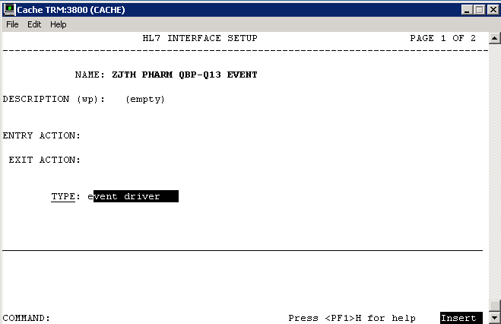

Figure 20: Example of Configuration of a Protocol to handle QBP-Q13 Events

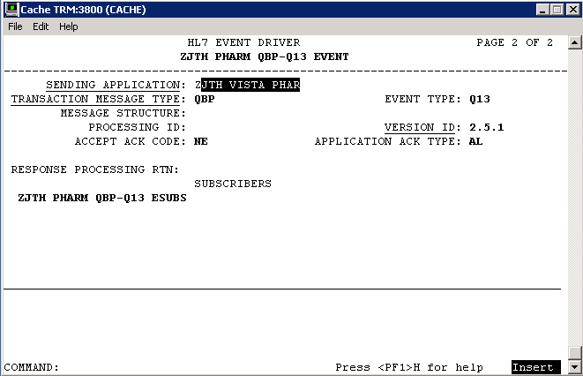

Figure 21: Example of Configuration of a Protocol to handle QBP-Q13 Events

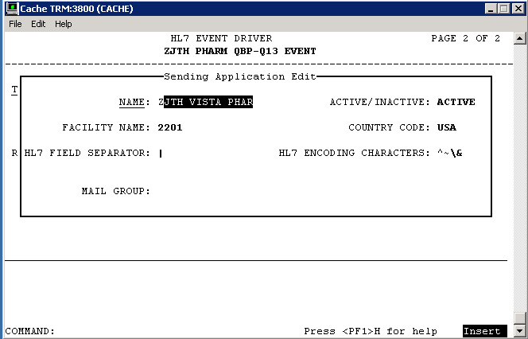

Figure 22: Example of Configuration of a Protocol to handle QBP-Q13 Events

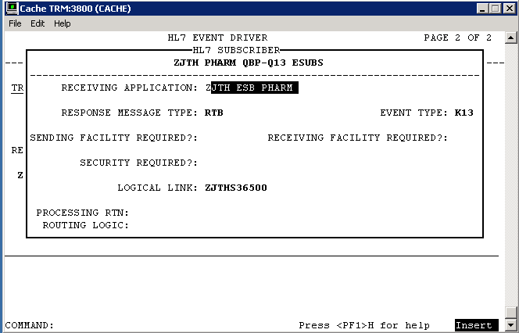

Figure 23: Example of Configuration of a Protocol to handle QBP-Q13 Events

### HL7 Sender and Receiver Applications

Sender and Receiver HL7 applications will be configured in VistA to fill MSH-3, 4, 5 and 6 fields. The Sending Application Facility Name is used to convey the site number of the VistA. The following is an example configuration of applications used in the protocols above:

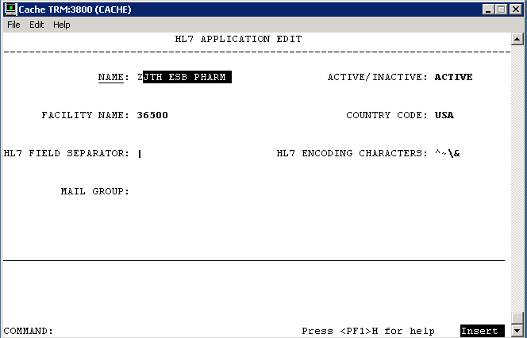

Figure 24: Receiving HL7 Application Configuration

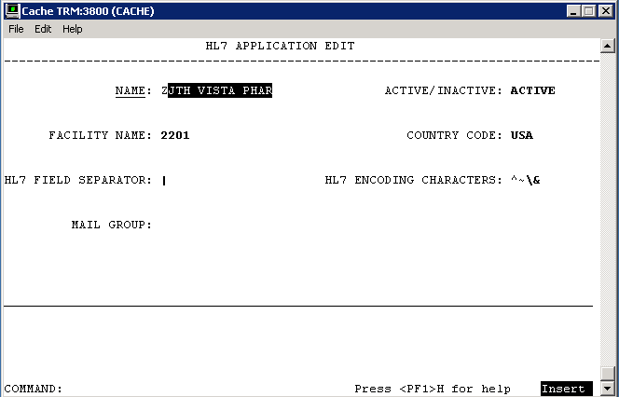

Figure 25: Sending HL7 Application Configuration

### Sender and Receiver Logical Links

A client logical link will be configured in VistA with the IP and Port of the VAeMI ESB. Additionally, a server or listening logical link will be added. HL7 messaging will be used to exchange requests between the initiating VistA and the VAeMI ESB. The following is an example configuration of logical links used in the applications above:

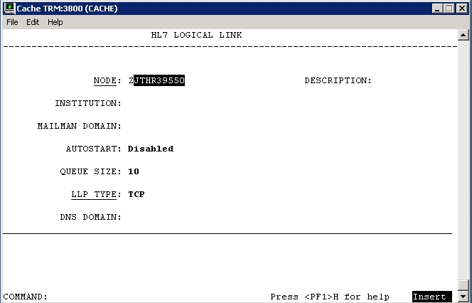

Figure 26: Example of Configuration of Logical Links

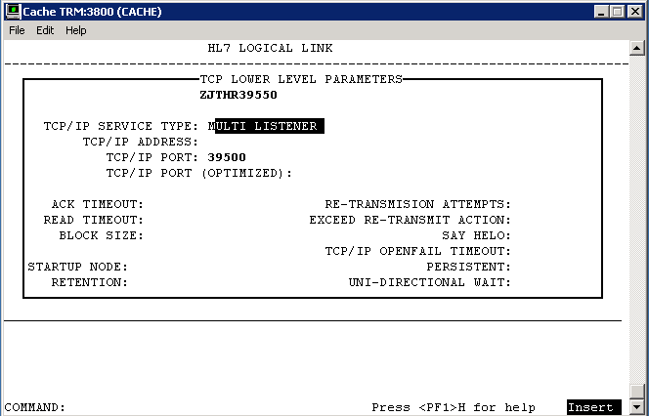

Figure 27: Example of Configuration of Logical Links

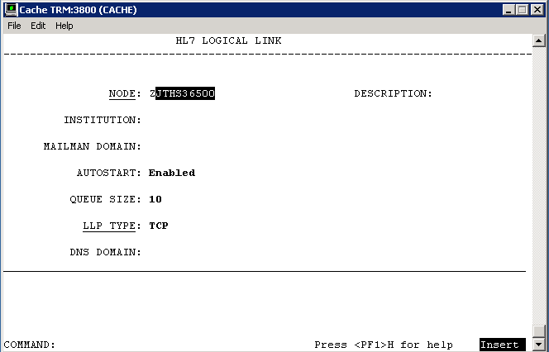

Figure 28: Example of Configuration of Logical Links

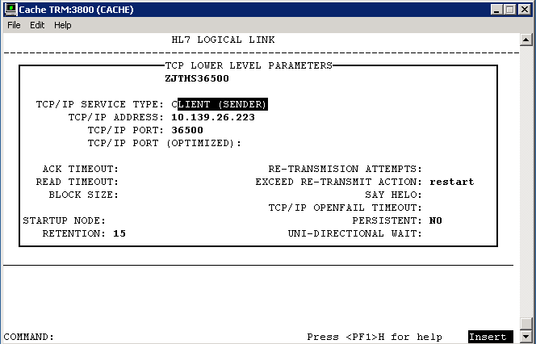

Figure 29: Example of Configuration of Logical Links

##### HL7 Logical Link

Table 56: HL7 Logical Link

| HL7 Logical Link | Description |
| --- | --- |
| **HL7 Logical Link Parameter Name** | **PSOR39550** - NAME CHANGE REQUIRED** |

|  |  |  |  |  |
| --- | --- | --- | --- | --- |
| **Enhancement Category** | **New** | **Modify** | **Delete** | **No Change** |

| Enhancement Category | Current | Modified |
| --- | --- | --- |
| **Node** | **N/A** | **ALL??** |
| **Institution** | **N/A** | **N/A** |
| **Domain** | **N/A** | **N/A** |
| **Autostart** | **N/A** | **Disabled** |
| **Queue Size** | **N/A** | **10** |
| **LLP Type** | **N/A** | **TCP** |

| HL7 Logical Link | Description |
| --- | --- |
| **HL7 Logical Link Parameter Name** | **PSOS36500** - NAME CHANGE REQUIRED** |

|  |  |  |  |  |
| --- | --- | --- | --- | --- |
| **Enhancement Category** | **New** | **Modify** | **Delete** | **No Change** |

| Enhancement Category | Current | Modified |
| --- | --- | --- |
| **Node** | **N/A** | **ALL??** |
| **Institution** | **N/A** | **N/A** |
| **Domain** | **N/A** | **N/A** |
| **Autostart** | **N/A** | **Enabled** |
| **Queue Size** | **N/A** | **10** |
| **LLP Type** | **N/A** | **TCP** |

##### COTS Interface

Not applicable.

## Network Detailed Design

The Network Design is a VA implementation and not being changed by the software being implemented within OneVA Pharmacy.

## Security and Privacy

### Security

#### Secure Sockets Layer (SSL)

The OneVA Pharmacy architecture does not use SSL to transport HL7 from VistA to/from the VAeMI ESB. The use of SSL is achieved from to the VAeMI ESB to the HDR/CDS. The scope and complexity of the changes required to VistA to support HL7 over SSL are unknown.

#### Authentication and Authorization

OneVA Pharmacy authentication and authorization occur fully within the context of existing VistA systems and as such rely on the pre-existing compliance of these applications with the security and privacy requirements and their resulting authentication and authorization.

#### Remote Prescription Locking

Before any action is taken on a remote prescription, the prescription is locked. The lock only remains long enough for the routines to file the data, which is generally only a few milliseconds. This prevents a ‘remote’ refill or partial fill from occurring in the event that a user at the originating site is taking action on the same patient’s prescription.

### Privacy

OneVA Pharmacy privacy standards occur fully within the context of existing VistA systems and as such rely on the pre-existing compliance of these applications with the security and privacy requirements.

## Service Oriented Architecture / ESS Detailed Design

Services provided includes:

* Provides: Transport of HL7 messages to target VistA
* Provides: Proxy call to the HDR for a patient’s active prescriptions.
* Consumes: HDR query service

### Service Description for <Consumed Service Name>

Not Applicable. No development of new service.

### Service Design for <Provided Service Name>

Not Applicable. No development of new service.

# External System Interface Design

## Interface Architecture

## Interface Detailed Design

HL7 v2.5.1 messaging is used to communicate between VistA and the VAeMI ESB. The following codes are provided for reference.

## Acknowledgement Codes

Table 14: Acknowledgement Codes

| Code | Status | Description |
| --- | --- | --- |
| AA | Application Accept | Requested action or operation was successfully performed |
| AR | Application Reject | Requested action or operation failed due to service errors |
| AE | Application Error | Requested action or operation failed due to HL7 message or semantic errors |

## Order Control Codes

Table 15: Order Control Codes

| Code | Status |
| --- | --- |
| RF | Refill order request |
| PF | Partial fill order request* |
| AF | Order refill authorization request approved |
| DF | Order refill authorization request denied |
| FU | Order refilled unsolicited at patient’s request |
| OF | Order refilled as requested by placer system |

*PF is not an HL7 standard code

## Remote Prescription Query Transaction

The remote prescription query request is a QBP^Q13 message type and the response is a RTB^K13 message type. The “Chapter” reference below refers to the HL7 Standard Version 2.5.1 documentation.

### Remote Prescription Query Request

The QBP^Q13 request is defined in Table 4. The implementation will ignore RDF and DSC segments and additionally, any segment not shown below is ignored.

Table 16: Remote Prescription Query Request

| QBP^Q13 | QBP Message | Chapter |
| --- | --- | --- |
| MSH | Message Header Segment | 2.15.9 |
| QPD | Query Parameter Definition | 5.5.4 |
| PID | Patient Identification | 3.4.2 |
| [RDF] | Table Row Definition Segment | 5.5.6.6 |
| RCP | Response Control Parameter | 5.5.6 |
| [DSC] | Continuation Pointer | 2.15.4 |

Table 17: QPD Field Description and Commentary

| Field Seq | Field Name | HL7 Data Type | Description |
| --- | --- | --- | --- |
| 1 | Message Query Name | CE | Must be Q13^Active Prescriptions^HL70471 |
| 2 | Query Tag | ST | Unique to each query message instance |

Table 18: PID Field Description and Commentary

| Field Seq | Field Name | HL7 Data Type | Description |
| --- | --- | --- | --- |
| 1 |  |  | Ignored |
| 2 |  |  | Ignored |
| 3 | MRN | CX | One or more patient identifiers may be sent. Each site provided and configured will be queried for prescriptions. |
| n |  |  | Ignored |

RCP Field Description and Commentary

Table 19: RCP Field Description and Commentary

| Field Seq | Field Name | HL7 Data Type | Description |
| --- | --- | --- | --- |
| 1 | Query Priority | ST | Must be “I” for Immediate |
| n |  |  | Ignored |

### Sample QBP^Q13 Request

**MSH**|^~\&|PSO VISTA PHARM|2101|PSO MIRTH PHARM|36500|20140102125951-0500||QBP^Q13|301|T|2.5.1|||NE|AL|USA

**QPD**|Q13^Active Prescriptions^HL70471|512123456

**PID**|||1666000286V397907^^^USVHA^NI^200M~100232^^^USVHA^PI^500~100445^^^USVHA^PI^612~100232^^^USVHA^PI^2204~100232^^^USVHA^PI^2202

RCP|I

### Remote Prescription Query Response

The RTB^K13 response is defined as follows.

Structure for the RTB^K13 message

Table 20: Remote Prescription Query Response

| RTB^K13 | QBP Message | Chapter |
| --- | --- | --- |
| MSH | Message Header Segment | 2.15.9 |
| MSA | Message Acknowledgement | 2.15.8 |
| [ERR] | Error | 2.15.5 |
| QAK | Query Acknowledgement | 5.5.2 |
| ZAK | Z-Segment | Defined below |
| QPD | Query Definition Segment | 5.5.4 |
| RDF | Table Row Definition Segment | 5.5.6.6 |
| [{RDT}] | Table Row Data Segment | 5.5.6 |

An ERR segment will be sent when MSA.1 acknowledgement code is AR or AE.

Table 21: RCP Field Description and Commentary

| Field Seq | Field Name | HL7 Data Type | Description |
| --- | --- | --- | --- |
| 1 | Site Number | ST | VistA site number |
| 2 | Count returned | NM | Count of rows returned from VistA site |
| 3 | Success indicator | NM | 1 – success  0 – unknown error  -1 – connection failure  -2 – response timeout |

The RDF segment and data in the RDT segment contains the following fields:

* Site Number
* Rx Number
* Drug Name
* Quantity
* Refills
* Days Supply
* Expiration Date
* Issue Date
* Stop Date
* Last Fill
* Sig
* Detail

### Sample RTB^K13 Response

**MSH**|^~\&|PSO MIRTH PHARM|36500|PSO VISTA PHARM|2101|20140109155138.281-0500||ACK^Q13^ACK|19|T|2.5.1

**MSA**|AA|50022643

**QAK**|512123456|OK|Q13^Active Prescriptions^HL70471|2

**ZAK**|2302|3|1|Success

**ZAK**|2303|0|-1|Connection timeout.

**RDF**|12|Site Number~Rx Number~Drug Name~Quantity~Refills~Days Supply~Expiration Date~Issue Date~Stop Date~Last Fill Date~Sig~Detail

**RDT**|2302|501109|NAPROXEN 250MG TAB|60|11|30|20150517.000000|20140516.000000|20150517.000000|20140516.000000|TAKE ONE TABLET BY MOUTH TWICE A DAY|NAPROXEN 250MG TAB Qty: 60 for 30 days

**RDT**|2302|501110|RANITIDINE HCL 25MG EFFER TAB|60|6|30|20150517.000000|20140516.000000|20150517.000000|20140516.000000|DISSOLVE 1 MOUTH TWICE A DAY|RANITIDINE HCL 25MG EFFER TAB Qty: 60 for 30 days

**RDT**|2302|501123|ACETAMINOPHEN 325MG TAB|240|5|30|20150726.000000|20140725.000000|20150726.000000|20140814.000000|TAKE TWO TABLETS BY MOUTH EVERY 6 HOURS AS NEEDED |ACETAMINOPHEN 325MG TAB Qty: 240 for 30 days

## Remote Prescription Dispense Transaction

The remote prescription refill dispense request is a RDS^O13 message type and the response is a RRD^O14 message type. This message is used to convey that the requesting system wishes to lock the remote order. The “Chapter” reference below refers to the HL7 Standard Version 2.5.1 documentation.

### Remote Description Dispense Request

The RDS^O13 request is defined in the following table and any segment not shown is ignored.

Table 22: Remote Description Dispense Request

| RDS^O13 | RDS Message | Chapter |
| --- | --- | --- |
| MSH | Message Header Segment | 2.15.9 |
| PID | Patient Identification | 3.4.2 |
| ORC | Common Order | 4.5.1 |
| RXO | Pharmacy/Treatment Prescription Order | 4.14.1 |

Table 23: PID Field Description and Commentary

| Field Seq | Field Name | HL7 Data Type | Description |
| --- | --- | --- | --- |
| 1 |  |  | Ignored |
| 2 |  |  | Ignored |
| 3 | MRN | CX | One or more patient identifiers may be sent. Each site provided and configured will be queried for prescriptions. |
| n |  |  | Ignored |

Table 24: ORC Field Description and Commentary

| Field Seq | Field Name | HL7 Data Type | Description |
| --- | --- | --- | --- |
| 1 | Order Control | ID | **Error! Reference source not found.** **Error! Reference source not found.** |
| 2 | Placer Order Number | EI | The originating order prescription number |
| 3 |  |  | Ignored |
| 4 |  |  | Ignored |
| 5 |  |  | Ignored |
| 6 |  |  | Ignored |
| 7 |  |  | Ignored |
| 8 |  |  | Ignored |
| 9 | Date/Time Transaction | TS | Date/Time of request |
| 10 | Entered By | XCN | Provides pharmacist identifier and name |
| 11 |  |  | Ignored |
| 12 |  |  | Ignored |
| 13 | Enterer’s Location | PL | Provides pharmacist’s site number |
| 14 | Call Back Phone Number | XTN | Provides pharmacist’s callback phone number |

Table 25: RXO Field Description and Commentary

| Field Seq | Field Name | HL7 Data Type | Description |
| --- | --- | --- | --- |
| 1 |  |  | Ignored |
| 2 |  |  | Ignored |
| 3 |  |  | Ignored |
| 4 |  |  | Ignored |
| 5 |  |  | Ignored |
| 6 |  |  | Ignored |
| 7 |  |  | Ignored |
| 8 | Deliver-To Location | LA1 | Provides (W)indow, (M)ail and requesting site number |

Sample RDS^O13 Refill Request

**MSH**|^~\&|PSO VISTA PHARM|2201|PSO ESB PHARM|36500|20140415110833-0500||RDS^O13|50024242|T|2.5.1|||NE|AL|USA

**PID**|||1666000286V397907^^^USVHA^NI^200M~100232^^^USVHA^PI^2202

**ORC**|RF|500974^2202|||||||20140415|1^PROGRAMMER^ONE|||^^^500|6655544

**RXO**||||||||W^^^2201

Sample RDS^O13 Partial Fill Request

**MSH**|^~\&|PSO VISTA PHARM|2201|PSO ESB PHARM|36500|20140716081903-0500||RDS^O13|50030627|T|2.5.1|||NE|AL|USA

**PID**|||1111000440V046182^^^USVHA^NI^200M~101016^^^USVHA^PI^2202

**ORC**|PF|501145^2202|||||||20140710|10000000225^TERRELL^GAIL|||^^^500|502-233-2355

**RXO**|1|10||||||W^^^500|||10

**NTE**|1|L|test

### Remote Description Dispense Response

The RRD^O14 response is defined as follows.

Table 26: Remote Description Dispense Response

| RRD^O14 | RRD Message | Chapter |
| --- | --- | --- |
| MSH | Message Header Segment | 2.15.9 |
| MSA | Message Acknowledgement | 2.15.8 |
| [ERR] | Error | 2.15.5 |
| ORC | Common Order | 4.5.1 |
| RXD | Pharmacy/Treatment Dispense Segment | 4.14.1 |

An ERR segment will be sent when MSA.1 acknowledgement code is AR or AE.

Table 27: RXD Field Description and Commentary

| Field Seq | Field Name | HL7 Data Type | Description |
| --- | --- | --- | --- |
| 1 |  |  | Ignored |
| 2 | Dispense/Give Code | CE | National Drug Code (NDC) |
| 3 | Date/Time Dispensed | TS |  |
| 4 | Actual Dispense Units | CE |  |
| 5 |  |  | Ignored |
| 6 |  |  | Ignored |
| 7 | Prescription Number | ST | Format: PSOIEN::REFIEN |
| 8 | Number of Refills Remaining | NM |  |
| 9 |  |  | Ignored |
| 10 | Dispensing Provider | XCN |  |
| 11 |  |  |  |
| 12 | Total Daily Dose | CQ | Days Supply |

Sample RRD^O14 Refill Response

MSH|^~\&|PSO ESB PHARM|36500|PSO VISTA PHARM|2302|20140723091250.151-0400||ACK^O13^ACK|12173|T|2.5.1

MSA|AR|50024459

PID|||1111000449V272697^^^USVHA^NI^200M~101044^^^USVHA^PI^2303

ORC|UF|501109^2303|||||||20140723|10000000225^TERRELL^GAIL|||^^^500|490-444-5555

Sample RRD^O14 Partial Fill Response

**MSH**|^~\&|PSO ESB PHARM|36500|PSO VISTA PHARM|2201|20140716081939.298-0400||ACK^O13^ACK|10412|T|2.5.1

**MSA**|AA|50030627

**NTE**|1||Partial complete for RX #501145.

**PID**|||1111000440V046182^^^USVHA^NI^200M~101016^^^USVHA^PI^2202

**ORC**|OF|501145^2202|||||||20140710|10000000225^TERRELL^GAIL|||^^^500|502-233-2355

**RXD**|1|^NAPROXEN 125MG/5ML SUSP^NDC|20140710000000-0400|10|||404366::1|||^RADIOLOGIST^ONE^^^^^^^^^^^^^2&VEHU SITE^^^20140717162300-0400||10

# Human-Machine Interface

The OneVA Pharmacy project will utilize existing Vista functionality to the fullest extent possible.

## Interface Design Rules

Not Applicable.

## Inputs

Not Applicable

## Outputs

TBD

## Navigation Hierarchy



Figure 30: Navigational Hierarchy

### Prescription Display

PSO LM BACKDOOR ORDERS will be modified to display remote Rx’s in the same screen where the local Rx’s are displayed for a patient. The remote prescriptions will occur after any local Rx’s and will have a section header ‘-----SITE NAME (SITE NUMBER)----‘delineation. Leveraging existing functionality means less training, and more immediate familiarity with the process.

Once the user selects to ‘Refill’ or ‘Partially Refill’, a prompt will display to enter the required information for sending a request to the ‘originating’ system, so that the refill or partial fill may be completed and the Rx data updated.

The ‘Select Order’ function within PSO LM BACKDOOR ORDERS will be modified to differentiate between the local and remote orders and pull from the remote order ^XTMP array when needed.

Once the user has selected the order, a new option will be available to either ‘refill remote order’ or ‘partial refill remote order’. The updates to the data will occur on the system of origin. Additional fields will be added to the Prescription file (#52) but have yet to be fully determined. The fields will include, remote pharmacist name, remote pharmacist phone number, and remote filling site.

A new local file will be added to hold the information about the remote prescription that has been filled. This file will contain information about the site, Rx number, pharmacist who filled the Rx, and the date the prescription was filled in the ‘local’ system. This file will be used for reporting and tracking purposes. Additional options may be made available for reprinting of labels.

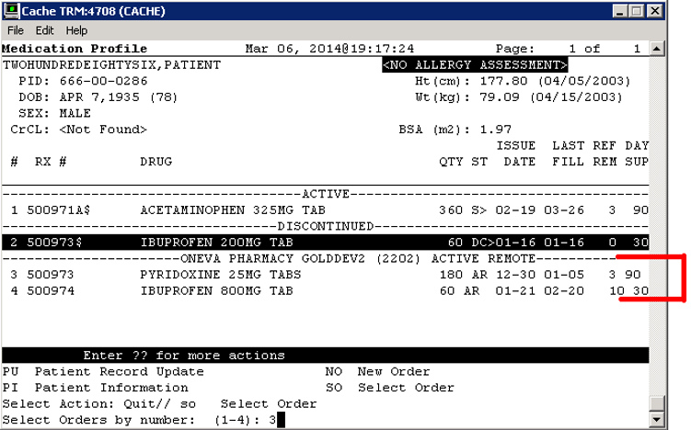

Figure 31: Medication Profile Screen Example – Remote Active Rx

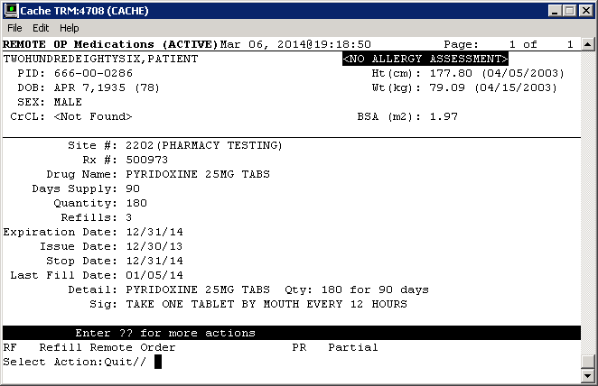

Figure 32: Remote OP Medication Screen

# Attachment A – Approval Signatures

This section is used to document the approval of the OneVA Pharmacy Implementation System Design Document during the Formal Review. The review should be ideally conducted face to face where signatures can be obtained ‘live’ during the review however the following forms of approval are acceptable:

1. Physical signatures obtained face to face or via fax

2. Digital signatures tied cryptographically to the signer

3. /es/ in the signature block provided that a separate digitally signed e-mail indicating the signer’s approval is provided and kept with the document

The following members of the governing Integrated Project Team (IPT) are required to sign. Please annotate signature blocks accordingly.

Signed:

______________________________________________________________________________

Joshua Patterson Date

Integrated Project Team (IPT) Chair

______________________________________________________________________________

Michael Valentino Date

Business Sponsor

______________________________________________________________________________

Cecelia Wray Date

Project Manager

1. Additional Information
   1. Identification of Technology and Standards

Reference materials includes the following:

* IEEE 2016-2009, Systems Design / Software Design Descriptions – <http://standards.ieee.org/findstds/standard/1016-2009.html>
* HL7 Messaging Standard v2.5.1 - <http://www.hl7.org/implement/standards/product_brief.cfm?product_id=144>
* VA118-13-R-0445, B.3 Performance Work Statement issued 2013-07-26
* Medical Domain Web Services (MDWS) documentation - <http://va.gov/vdl/application.asp?appid=192>
* HL7 (VistA Messaging) documentation - <http://va.gov/vdl/application.asp?appid=8>
* My HealtheVet documentation - <http://va.gov/vdl/application.asp?appid=153>
  1. Constraining Policies, Directives and Procedures

Not applicable.

* 1. Requirements Traceability Matrix

The Requirements Traceability Matrix (RTM) can be found on the VA SharePoint. The OneVA Pharmacy RTM can be access by following this LINK.

* 1. Packaging and Installation

There are no known special considerations for software packaging of this VistA patch and the installations instructions will be delivered with the OneVA Pharmacy Installation, Back out, and Roll Back Plan.

* 1. Design Metrics

Not applicable.